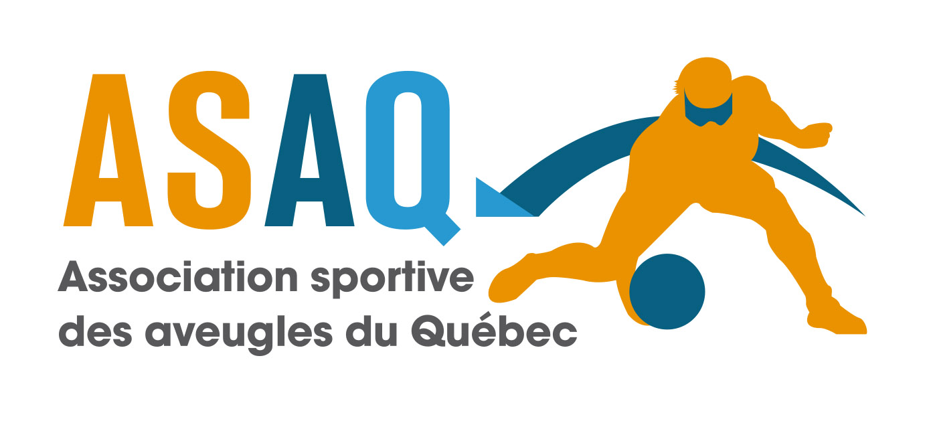
Montreal, October 17, 2025
Dear friends,
The Association sportive des aveugles du Québec (ASAQ) is pleased to invite you to the 24th edition of the Montreal Open Goalball Tournament (MOGT), taking place on January 23, 24, and 25, 2026, in Montreal, Quebec.
REGISTRATION FEES
- Option 1 – Early bird rate: $600 CAD per team for registrations received before Monday, November 24, 2025 (includes up to 6 players and 2 coaches/staff – add $50 per additional person).
- Option 2 – Regular rate: $700 CAD per team for registrations received between November 25 and the final deadline of Monday, December 8, 2025 (same conditions as above).
Payments must be made in Canadian dollars. A $10 CAD fee applies for payments in foreign currencies.
Registration fees and liability waiver forms must be received for registration to be confirmed. Please do not make travel arrangements until official confirmation is received.
REGISTRATION DEADLINE
Registrations received after December 8, 2025, will be considered based on availability and at the discretion of the organizers.
CANCELLATION POLICY
A fee of $250 CAD per team will be charged for cancellations after January 1, 2026. Upon receipt of a written cancellation request, a team on the waiting list may take the available spot.
TOURNAMENT CAPACITY
- Men’s tournament: First 10 paid and registered men’s teams.
- Women’s tournament: First 6 paid and registered women’s teams.
Important note: To encourage diverse representation, we ask that only one men’s and one women’s team be registered per province or state. A notice will be issued after the first round of registrations to confirm if additional teams may be accepted.
TOURNAMENT SCHEDULE
- Start: Friday, January 23, 2026 at 6:00 PM.
- Finals: Sunday, January 25 at 1:00 PM, followed by medal ceremonies.
RULES
The latest IBSA rules will apply, except for the number of matches per day, which may exceed the recommendation depending on the tournament schedule.
COACHES MEETING
A coaches meeting will be held at the tournament venue.
TOURNAMENT VENUE
Gadbois Recreation Complex
5485 Ch. De la Côte-Saint-Paul, Montreal, Quebec, Canada
VENUE SECURITY
We recommend not bringing valuables. Organizers are not responsible for loss or theft.
ACCOMMODATION
As in the previous tournament, we will be using the same hotel:
Le Nouvel Hôtel Montréal
1740 Boul. René-Lévesque Ouest
Montreal, Quebec H3H 1R3
Hotel virtual tour: https://tour.avenue360.ca/fr/tour/le-nouvel-hotel
Contact: Mourad Othman, Sales Director
Mobile: 514-883-9654
Email: mothman@lenouvelhotel.com
Rate: $152 CAD per night (plus taxes), up to 4 people per room.
Please note that a Group Code will be available shortly and sent in a separate email.
Reservations must be made before January 8, 2026. After this date, you will need to arrange your own accommodation.
Please provide the full name of each athlete and coach for each reserved room.
*You must use a valid credit card to reserve your rooms. Please note that the final payment for the rooms will be charged to the card 48 hours before your arrival. If for any reason you need to cancel or modify your reservation, please contact Mourad directly at the hotel.

EQUIPMENT
- Balls: The official ball will be the KSG goalball. Two warm-up balls will be provided. Lost or stolen balls will not be replaced.
- Eyeshades and eye patches: Teams must bring their own eyeshades. Eye patches will be provided for each match. Eyeshades will not be provided by the organizers. Regular eyeshades are standard, but teams may also use the international competition model with nose protection.
- Jerseys: Numbers must be permanently affixed to the front and back, with contrasting colors.
MEALS
Meals will be provided by the organizers on Friday and Saturday evenings, and Saturday and Sunday for lunch. Breakfast is the responsibility of participants, but snacks (muffins, bagels, fruit, tea and coffee) will be available at the gym cafeteria.
TRANSPORTATION
A shuttle service will be available between Le Nouvel Hôtel and the competition site for all participants.
PHYSIOTHERAPY
A physiotherapist will be available free of charge on-site for all teams during the tournament.
For any questions, feel free to contact us by email at:
📧 directiongenerale@sportsaveugles.qc.ca or projets@sportsaveugles.qc.ca
We look forward to welcoming you in January for the 24th edition of the Montreal Open Goalball Tournament!
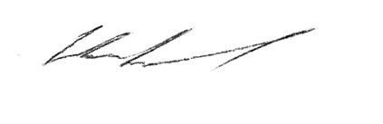
Marc Lemieux
Executive Director, ASAQ

