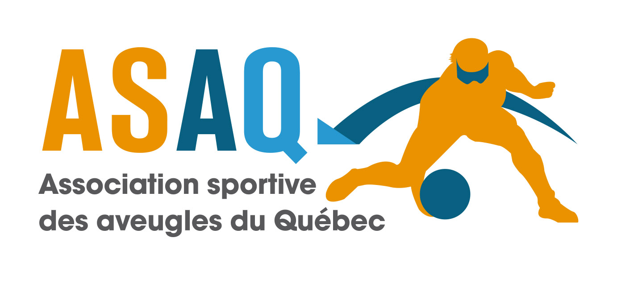

REGISTRATION FORM - 2025 MOGT
(1 per team)
PROVINCE-STATE:

Team’s name:
Coach’s name:
Number of players:
The name and number of each player: (6 maximum)

First Name :
Last Name:
Number :

First Name :
Last Name:
Number :

First Name :
Last Name:
Number :

First Name :
Last Name:
Number :

First Name :
Last Name:
Number:

First Name :
Last Name:
Number:

Team gender:

CONTACT PERSON
Contact name:
Contact adress:
Contact phone number: (work)
Contact phone number: (HOME)
E-mail address:
Total number of people:

What kind of transportation are you going to use? (tick the right box)
Flight
Train
Ground transportation (car,van)
Or other

If you select other please precise :
Time of arrival in Montreal:
Time of departure from Montreal:

From this part you have to use your “arrow key” please.
.

Cheques should be made out to “ASAQ”, please take note of our new address (see below).

The fees for this year are:
OPTION 1: Prior to Early Bird date of Friday November 24th, 2024 $550.00 CAD* per team (maximum of 6 players and 2 coaches)
OPTION 2: Prior to Tournament Deadline date of Friday December 8th, 2024: $650.00 CAD* per team (maximum of 6 players and 2 coaches)
*Canadian dollars only, otherwise add $10.00 for foreign currency exchange fee!

You may pay by Visa or Mastercard:
Card number:
Expiration:
Signature of the card owner:
CVV code:

You may pay by Interac transfer (e-transfer) at :
infoasaq@sportsaveugles.qc.ca
reason : MOGT
Password : goalball

Marc Lemieux
Executive Director
A.S.A.Q.
7665, boulevard Lacordaire
Montréal (Quebec) H1S 2A7
Tel: 514-252-3178 ext. 3768
directiongenerale@sportsaveugles.qc.ca

