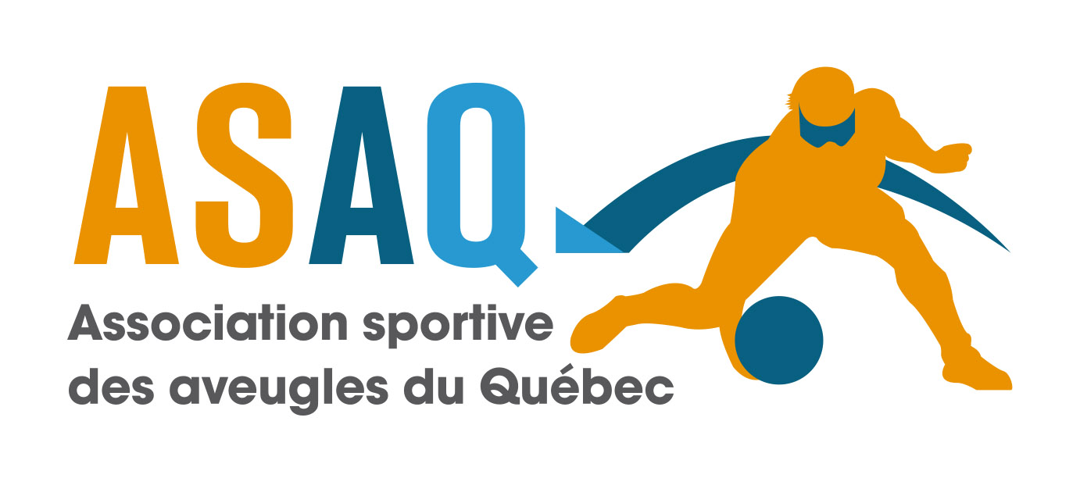
Montreal, October 21st 2024

Dear friends,

The Association sportive des aveugles du Québec (ASAQ) is proud to host the 23rd Montreal Open Goalball Tournament in Montreal, Quebec, January 24th, 25th and 26th, 2025.

REGISTRATION FEES

OPTION 1: Early Bird discount when you register before Monday November 25th, 2024: $550 CAD* per team (maximum of 6 players and 2 coaches)
OPTION 2: Registration before the deadline on December Friday 8th, 2024: $650 CAD* per team (maximum of 6 players and 2 coaches)
* We ask teams to pay in Canadian dollars; otherwise, a $10 CAD foreign currency exchange fee will be applied!

Registration fees and all liability waivers must be received before a team’s registration can be confirmed. We are not responsible for travel arrangements made before registration is officially confirmed.

REGISTRATION DEADLINE
Entries after the deadline of December 8th, 2024 will be considered at the discretion of the tournament organizers and subject to availability.

CANCELATION POLICY
A cancellation fee of $200 CAD per team will be charged for cancellations after January 1st, 2025. Upon receiving a written cancellation request, a team on the waiting list will be immediately given the cancelling team’s spot.

TOURNAMENT CAPACITY
The 23rd Montreal Open can accept the following:
MEN’S TOURNAMENT: The first 10 fully paid and registered men’s teams.
WOMEN’S TOURNAMENT: The first 6 fully paid and registered women’s teams.

ARRIVAL & TOURNAMENT COMMENCEMENT
The competition will start on Friday, January 24th, 2025 at 6:00 PM. It is your responsibility to arrive on time for Friday’s scheduled games.

TOURNAMENT FINALS & DEPARTURE
The final games will take place on Sunday January 26th at 1 : 00 pm with medal ceremonies to immediately follow . It is your responsibility to be available through to the end of the tournament.

TOURNAMENT RULES
We will apply the 2022-2024 IBSA rules with the only exception being number of games played in a day; the tournament schedule may require teams to play more games than the IBSA rules recommend.

COACHES MEETING
There will be a coaches’ meeting in the venue.

TOURNAMENT VENUE
Complexe récréatif Gadbois
5485, chemin Côte St-Paul, Montreal, Quebec, Canada

VENUE SECURITY
We recommend not bringing any belongings of sentimental or monetary value to the venue. Tournament organizers are not responsible for lost or stolen items.

ACCOMMODATIONS

Le Nouvel Hotel Montreal
1740 Rene-Levesque O.
Montreal Quebec H3H 1R3

Tour virtuel de l’hotel / Virtual tour of hotel
https://tour.avenue360.ca/fr/tour/le-nouvel-hotel

Hotel Contact:
Mourad Othman
Le Nouvel Hôtel Montreal
Gérant Des Ventes / Sales Director
Cell: 514-883-9654
mothman@lenouvelhotel.com

We have reserved 30 double rooms at the Nouvel Hotel for $149 CAD per night (taxes not included) with a capacity of four people per room.

ALL ROOMS ARE RESERVED UNDER CODE: “MOGT 2025”
A credit card is required to pay for your rooms.

There are 4 ways to book your rooms:
- Call: 514-931-8841 ext 2605 or 1-800-363-6063 (ask for Mourad)
- Fax: 514-931-5581 (Attn of Mourad)
- Email: mothman@nouvelhotel.com
- Website: https://www.lenouvelhotel.com/ (Use Group Code : MOGT 2025) *Please note that the group code will be available starting from October 25, 2024.

It is your responsibility to book and pay for your reserved rooms. You have until January 8th to do so; after this date, you will have to arrange your own accommodation.

Please note: you must give the full name of each athlete and coach in each room to facilitate the booking.

GOALBALLS
The game ball will be the KSG goalball. We will provide 2 warm up balls. If during the tournament they get lost or stolen, they will not be replaced.

EYESHADES AND PATCHES
Teams are responsible for bringing their own eyeshades. Eye patches will be provided at each game of the tournament.

*** EYESHADES WILL NOT BE PROVIDED BY TOURNAMENT ORGANIZERS ***

JERSEYS
Numbers must be permanently fixed to both the front and back of your jerseys and be contrasting colours.

MEALS AT VENUE
Meals will be served by the tournament organizers Friday and Saturday evening and Saturday and Sunday at noon. Breakfast is your responsibility. However there will be free muffins, bagels, toast, fruits, and tea and coffee at the gymnasium cafeteria.

TRANSPORTATION
Transportation will be provided to and from the Nouvel Hotel and the competition site for all visiting participants.

PHYSIOTHERAPY
A physiotherapist will be available on site at no charge for all teams during the tournament.

For more information, do not hesitate to call us at (514) 252-3178 extension 3768 or e-mail us at:
directiongenerale@sportsaveugles.qc.ca

We are looking forward to seeing you in 2025, for the 23rd edition of the Montreal Open!

Sincerely yours,


Marc Lemieux
Executive Director, ASAQ

