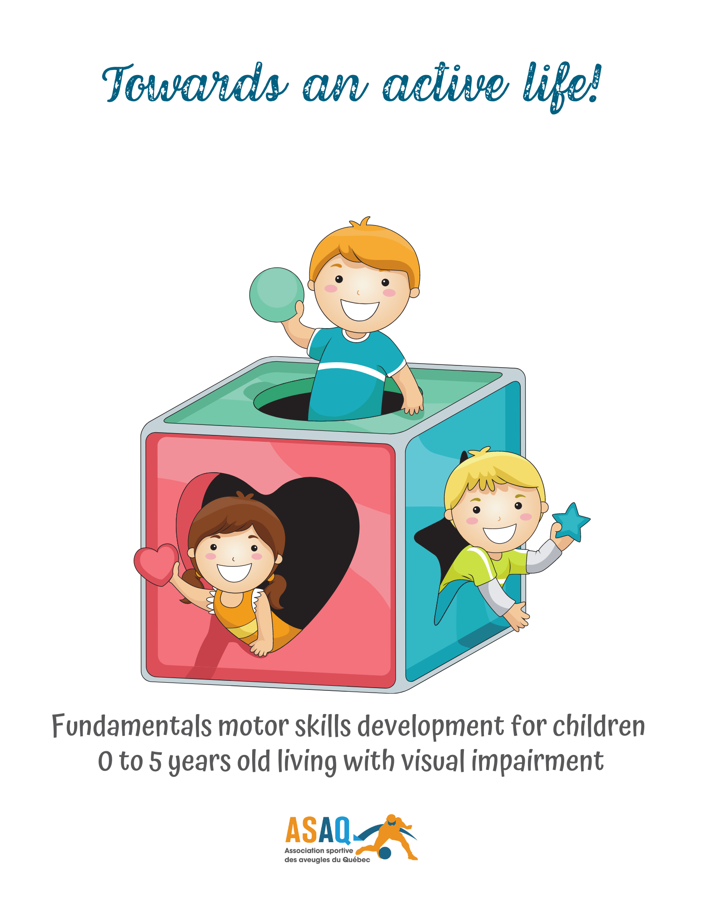

Partners
The guide Towards an active life! Fundamentals motor skills development for children 0 to 5 years old living with visual impairment was produced by the Québec Blind Sports Association (Association sportive des aveugles du Québec – ASAQ) in partnership with the following organizations:
Institut Nazareth et Louis-Braille (INLB) |  | Institut de réadaptation en déficience physique de Québec (IRDPQ)
Centre de réadaptation MAB-Mackay |  | Association québécoise des parents d'enfants handicapés visuels (AQPEHV).
La Maison des enfants de l’île de Montréal |  | Groupe d’entraide maternelle de la Petite Patrie (GEM)
British Columbia Blind Sports and Recreation Association (BCBSRA) |  | Malou Production

Table of Contents
Partners 3
Table of Contents 4
Introduction 5
What Are Fundamental Movement Skills? 5
Fundamental Movement Skills 6
Locomotion 6
Manipulation 6
Stability 6
Locomotor Development of Children with a Visual Impairment and Parental Challenges 7
How to Use This Guide 7
A Few Tips 8
Birth to 3 Months 11
Quick Reference List 13
3 to 6 Months 14
Quick Reference List 17
6 to 12 Months 18
Quick Reference List 21
12 to 18 Months 22
Quick Reference List 25
18 Months to 2 Years 27
Quick Reference List 32
2 to 3 Years 34
Quick Reference List 38
3 to 4 Years 39
Quick Reference List 42
4 to 5 Years 43
Quick Reference List 46
Conclusion 47
Some Helpful Resources 48
Acknowledgements 49
References 50

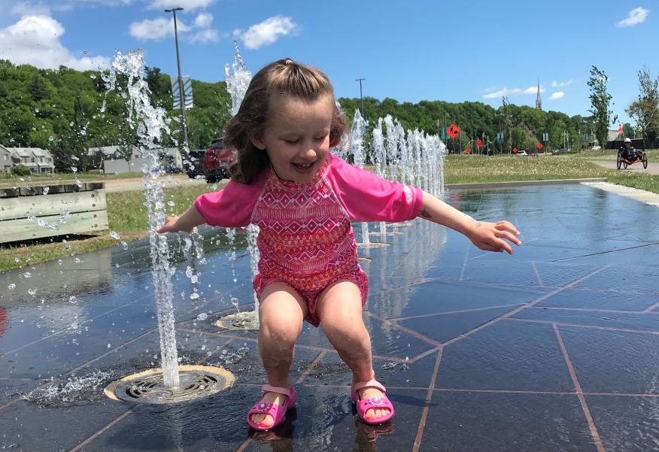

Introduction

The Quebec Blind Sport Association (ASAQ) has created this guide for parents of young children with a visual impairment to help them develop fundamental movement skills in the first five years of life. It is meant as a complement to the care and services provided by occupational therapists, physiotherapists, optometrists, orientation and mobility specialists and other rehabilitation professionals. To find a rehabilitation facility in Quebec, please refer to the list of resources at the end of the guide or contact ASAQ.

What Are Fundamental Movement Skills?
Fundamental movement skills (walking, running, jumping, throwing, catching, kicking, swimming, climbing, crawling, etc.) are a core component of physical literacy.
They are the building blocks for more complex skills used in a wide variety of games, activities, sports, and recreational pursuits and are one of the key factors that influence an individual’s participation in physical activity (https:/passportforlife.ca).
Watch video #1 - Introduction

Fundamental Movement Skills
A Partial List
Locomotion | Manipulation | Stability
Walking | Throwing | Bending over
Running | Kicking | Stretching
Leaping | Striking with an object | Twisting, pushing, pulling
Jumping | Bouncing, dribbling with the hands | Turning
Hopping | Rolling an object | Balancing
Combined movements | Catching | Falling
Galloping | Trapping with the feet | Getting up, lifting
Sliding |  | Leaning
Skipping |  | Maintaining balance in various ways
Climbing |  | Walking on a beam
 |  | Rolling on the ground, thrusting, stopping, dodging
Improving fundamental movement skill (FMS) competency helps develop gross motor control, which is the basis for fine motor skills that are essential to academic performance, including writing, drawing and other precision activities. What’s more, a child who is independent in their activities of daily living and has developed a good level of physical literacy will be more likely to socialize with their sighted classmates and make friends more easily.
It is common knowledge that an active lifestyle has multiple physical, social and emotional benefits. Children with a visual impairment need a little more help to develop their motor proficiency, especially considering that, for their sighted peers, 80% of learning occurs visually. But once they have acquired a range of fundamental movement skills, they will be better prepared to function independently, play sports, maintain an active lifestyle and engage with their community later in life.

Locomotor Development of Children with a Visual Impairment and Parental Challenges
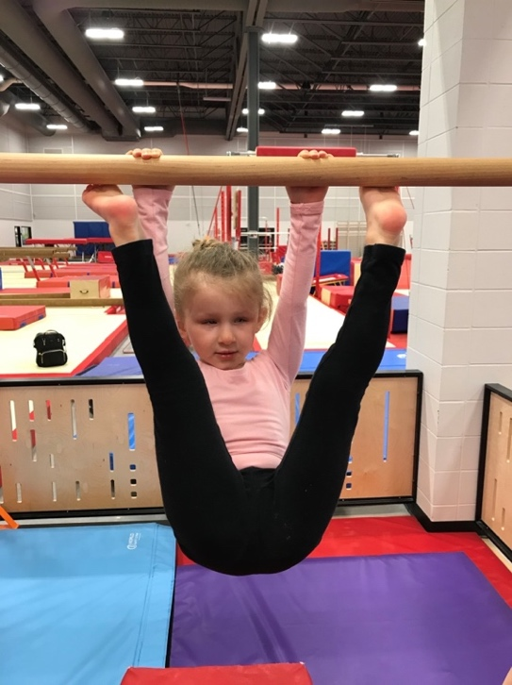
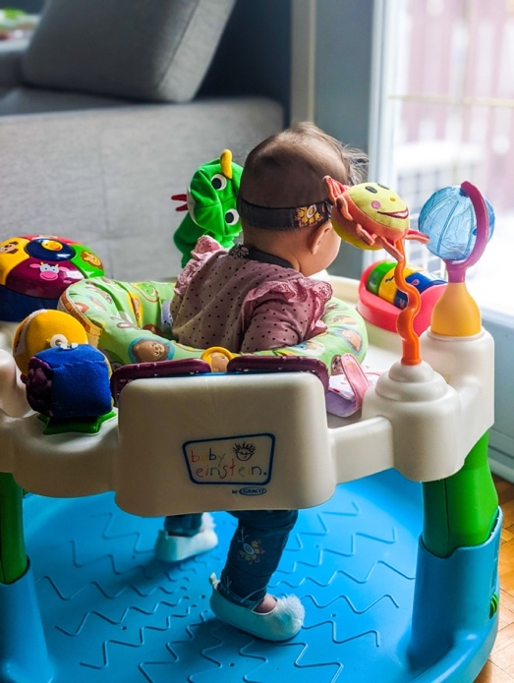
Babies with a visual impairment do not react the same way to the stimuli that typically motivates sighted babies to move, i.e., to advance toward something or someone they want. They do not perceive the movements of nearby people the same way, so they may be less inclined to imitate them. As a result, motor development tends to occur more slowly, and gaps often emerge. Nevertheless, these children are physically capable of developing the same physical and motor skills as those without a visual impairment. With the proper support and stimulation in line with their needs, these children have the potential to develop active lifestyle habits that will last them a lifetime. And the earlier these habits are instilled, the better!
This guide has been prepared to help give you the tools to support your child in acquiring and refining fundamental movement skills. It is never too early or too late to help your child become more active.

How to Use This Guide
This guide is divided into eight sections, according to age range. Each section comes with a video and a quick reference list. Please remember that the ages indicated are guidelines. Chronological age is only an approximate indicator of developmental readiness. The most important thing is to proceed methodically and to work with your child at whatever stage they are at. You are encouraged to review the sections that correspond to the previous and next stages of your child’s development to give you an idea of how they are progressing and what you are working toward. Every child will learn at their own pace, influenced by a host of factors, including their individual temperament, their interests, their level of vision, any other disabilities they may have, the quantity and quality of stimulation they receive, whether or not they have any siblings, and more.

A Few Tips
Let’s get started with a few general tips that will apply to the entirety of the guide and your efforts moving forward.
Opt for objects and toys that are adapted to your child’s abilities and level of development. You can also incorporate objects associated with the next stage of their development, if these objects are available and you deem them appropriate. That will give your child ample time and opportunity to explore and become familiar with them.
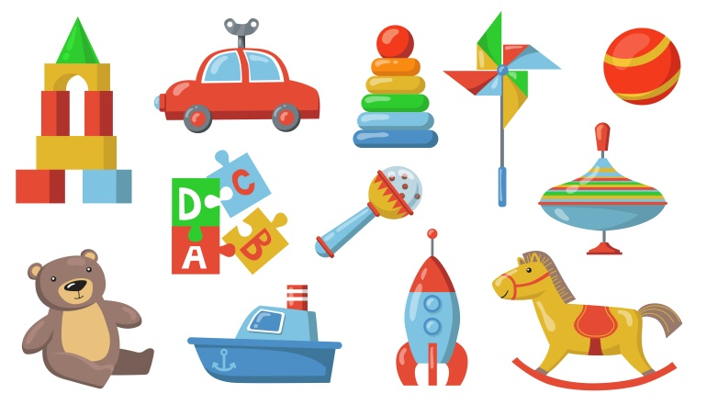
Whenever possible, expose your child to real-life things and animals. It is easy for a sighted child to make a distinction between toy dishes and real dishes, or between a plush cat and a real cat, but it is an entirely different experience for a child who is visually impaired or blind.
Be prepared to repeat the same exercises, the same games and the same words over and over again. All children learn through repetition, but a child with a visual impairment may take longer to reach the same milestones. It will also help if you always use the same words to identify an object or an action. That way, your child will know what to expect and feel more secure.
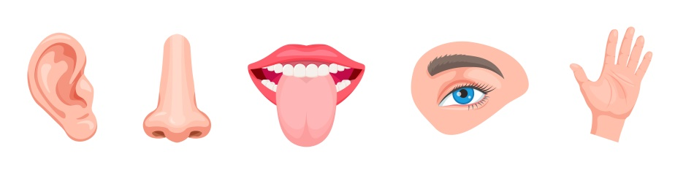
Vary sensory stimulation. Alternate between sight (if applicable), hearing, touch (different textures and temperatures), taste, smell and proprioception (body awareness, which involves making them feel other people’s movements and/or guiding them manually to move their body in a certain way). The idea is to elicit a response to an action so your child feels drawn to imitate the movement.

Be selective in your stimulation and watch for signs of overstimulation. Your child needs downtime, too. We will address this in more detail in the next section. Meanwhile, your best bet is to opt for short periods of active play frequently throughout the day. It’s also important to reduce auditory distractions when you are playing with and stimulating your child. That way, it will be easier for them to maintain their focus on what you are showing them. Over time, familiar sounds in their surroundings will be less disturbing.
Create a safe, secure environment where your child is free to move and explore. In other words, make sure there are no risks of hurting themselves, and be there to support them as needed.
Help your child engage in movement but let them do as much as they can on their own. For example, you can use a technique known as tactile modelling to move their legs to demonstrate a certain type of movement, but as soon as you can, let them figure the rest out for themselves!
Later on, when your child is able to do certain things on their own, it may put your patience to the test. Patience is important for all parents, but even more so for parents of a child with a visual impairment. You can help by breaking down movements into a series of steps. Depending on the movement, you may also want to start at the end and work backwards.
It may help you to think of the positive impact the work you are doing now will have on their future. The stronger their fundamental movement skills as a young child, the easier it will be for them to engage independently in a wide range of activities as they grow older. This includes getting around, eating, writing, interacting with other children at school, playing sports and more. It will also have a tremendous impact on their confidence and their self-esteem.
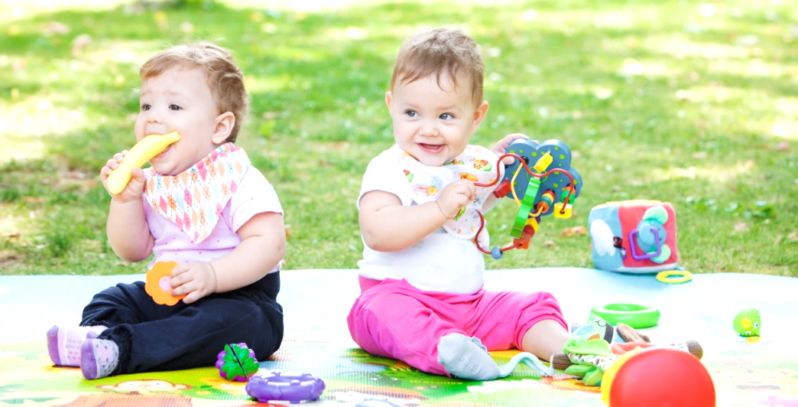
When starting out, gross motor skill development will inevitably take most of your time and focus. Gradually, you will branch out to work on a broader range of more advanced abilities.

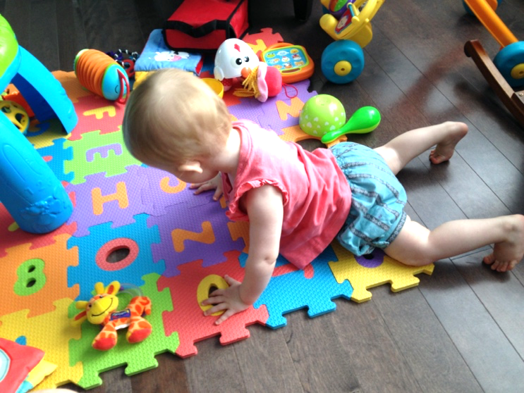
Canadian guidelines for physical activity and movement for children 5 and younger is 180 minutes per 24-hour period. Yes, that’s three hours a day! But remember: every movement counts as soon as the child is no longer sedentary (seated or in bed).
Think of these moments of helping your child to move as opportunities to play together quietly, to enjoy special moments of togetherness and to have fun. And feel free to get other family members involved. Make it a game: it’ll be more interesting for your child and for you!
You are your child’s first teacher, but you’re far from being their only source of learning. Reach out to grandparents, uncles, aunts, friends, neighbours and others. They’ll all have something positive to contribute and different ideas for getting your child moving. And it will take some of the burden of your own shoulders.
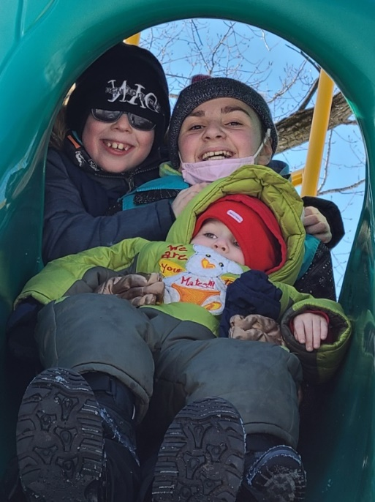

Birth to 3 Months

ying on her back. First and foremost, it is important to remember to watch your child for signs of overstimulation. If they start crying out of the blue, move in a jerky way, suddenly stretch out and arch their back, or turn away and “space out,” it may be because they need a break from stimulating things like ambient noise or the activities you are doing together. But going quiet can also be a sign of interest: you’ll have to learn the difference! It is important to create a safe, secure environment for your baby so they can move their body freely within that space. Keep auditory stimuli to a minimum. They can be a significant distraction to children who are visually impaired or blind. If the ambient temperature is warm enough, remove their socks and other pieces of clothing to expose their skin to the air, ground, and the objects and people around them. The increased body awareness will encourage them to move even more.
Routinely lie your baby down on the ground, on a blanket or a mat, rather than sit them in a chair, so they have more opportunity to move. You can enhance their environment by placing brightly coloured or high-contrast toys around them, or toys that make sounds or light up, making sure to watch for signs of overstimulation. If they are lying on their back, you can put metal or plastic boxes on either side of their head. The sound reverberation will prompt them to turn their head. And remember: the best source of stimulation is you. Talk and sing to them. This will help them learn to locate where the sounds are coming from.
Several times a day, for example during diaper changes, put your baby on their stomach, making sure to watch them carefully. They probably won’t tolerate the position for more than a few seconds in the beginning. But keep at it and gradually increase their amount of “tummy time.”
When they can stay there for several minutes, find different ways to make them lift their head, with sounds or visual stimuli if they have some sight. Once again, your voice is the best source of motivation. You can also use a mirror, light or rattle as appropriate. Another option is to gently rub the back of their neck, which may encourage them to lift their head.
You can also place two differently sized plastic plates under their head, which will make an interesting sound when they move or lift their head. Once they get used to that, you can add differently textured objects to the plates, like small pieces of fabric, or objects that make an interesting sound, like ping pong balls. You may also want to hang an object that makes a sound behind their head, like a chime or a jingle ball.
When your baby has better control over their head, try to get them to turn it as often as possible by placing stimulating objects slightly to the side, such as toys that make sounds or light up or have high-contrast or colourful patterns.
When your baby is quiet and receptive, after a feeding for example, sit them on your lap, with their back against your stomach and chest, and play with them. Clap their hands and tap their feet together while reciting a song or a nursery rhyme. Play with their fingers, too. The videos that accompany this guide have some suggested songs and rhymes you can use. You can also refer to these videos:
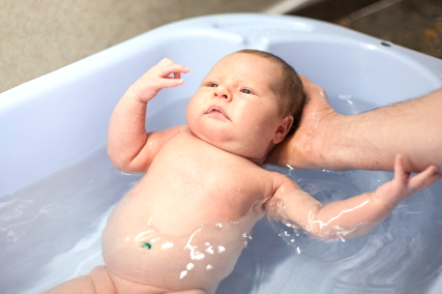
Pattycake (ou Pat-a-Cake) / This Little Piggy
Change their position regularly to help increase their body awareness. They’ll spend most of their time on their back, but turn them around occasionally to their stomach and side, while lying on top of you or using cushions, and always supervised. Bath time is a great opportunity to play with them in the water. You can also give your baby a massage. Many local organizations offer basic baby massage classes. Be sure to ask around.
The vestibular system, which helps control balance and spatial orientation, will be important as your child grows and learns to walk. You can stimulate this development now through swinging motions, either in a baby swing or in a baby carrier. A baby carrier can be a very pleasant and reassuring experience for your baby. They can feel your movements and your gait as you walk. The physical contact is also important in strengthening the parent/child bond. Touch is important for all babies, but it is vital for those whose eye contact and non-verbal language are altered or non-existent because of a visual impairment.
One last and crucial thing: get used to talking to your baby pretty much non-stop. You will have to verbalize and explain a lot to your child to compensate for the lack of visual cues. Make it a habit to describe what you’re up to, provide a blow-by-blow of the exercises you’re doing together, identify pleasant smells at home or outside, and explain where various sounds come from. Even before your baby understands your words, their brain is processing the sounds that will eventually develop into language. If your baby also has a hearing disability, the principle is the same: introduce tactile signing as early as possible.

Quick Reference List
Ideas for Stimulating My Child (Birth to 3 Months)*
*The ages provided are approximate. Your child may need stimulation from a different age range. Be sensitive and responsive to their needs, and proceed methodically from one stage to the next, without skipping.
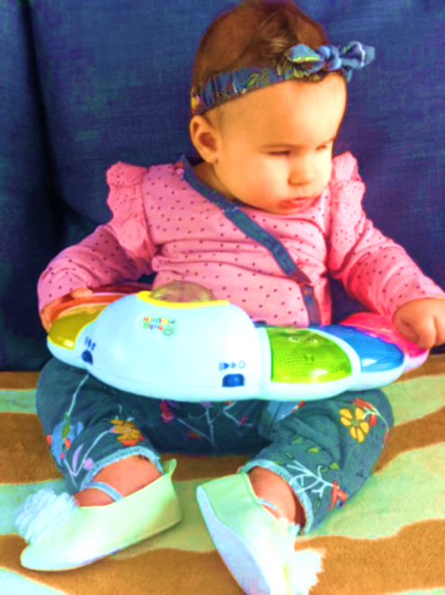
- Watch for signs that your child is relaxed and ready to play, or that they are overstimulated and need a break.
- Placing them on the ground on a blanket or playmat is preferable to sitting them up in a baby chair.
- Whenever possible, dress your child minimally in order to expose their skin to their surroundings.
- Get some “tummy time” in several times a day, working up from a few seconds to longer stretches of time.
- Place interesting toys around them (varying colours, patterns, sounds, lights, etc.) when they are alert and responsive to stimulation.
- When they are lying on their back, put metal or plastic boxes on either side of their head to change how the sound reverberates around them.
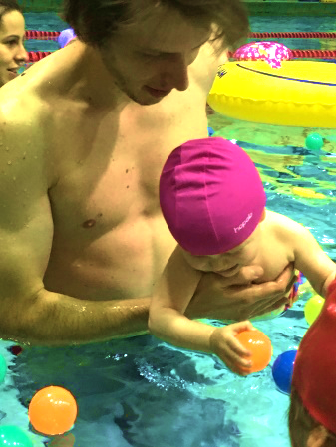
- Talk and sing to your child.
- Play in the water with your child.
- Vary their positions.
- Administer baby massages.
- Carry your baby around in a baby carrier (note that mothers should use baby carriers sparingly until six weeks postpartum).
Watch video #2 - Birth to 3 Months

3 to 6 Months

If you observe that your child is easily overstimulated, you may want to set up a quiet corner for them where distractions can be kept to a minimum. You can section it off with screens, for example, or favourite objects. Ideally, you should find a way to reduce outside noises. And if there is any kind of a structure around your child, make sure it is sturdy, so nothing falls on them.
When your child is lying on the ground, you can move different parts of their body. For example, you can put your hands on their feet and rotate their legs in a bicycle motion. Then let them take over and continue the same movement. The idea is to make them aware of the parts of their body they might not be able to see but they can feel.
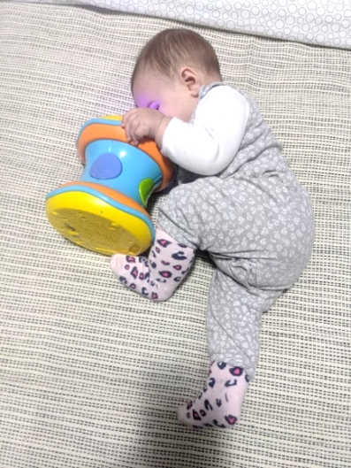
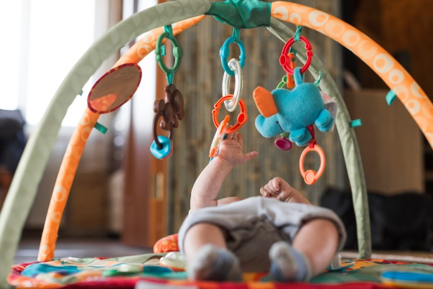
To encourage them to grasp objects, put toys they like within reach and attach them to something so the objects don’t “vanish” when your child lets go of them. For example, you can tie them to the posts of their bed, to their stroller or to the tray of their high chair. Play arches and baby gyms are great for when they’re lying on their back, a position that is more conducive to movement than sitting in a chair.
If your baby is now comfortable on their tummy and their head is stable, it’s time to learn how to roll over from stomach to back and vice versa. When they are lying on their back, you can help encourage this movement by bending their legs so they can touch their feet and then gently rocking their hips to the right and left.
While they are on their stomach, if they are already lifting their head up and pushing up on their hands, you can guide them by bending one knee up toward their midriff and rolling their hips. You can also tickle the inside of their elbow or use brightly coloured, high-contrast, light-up or sound-making objects they will reach out for. The idea is to show them the way and then gradually let them initiate the movement on their own. We recommend this YouTube video, and these : Videos for Parents of 4-6 Month Olds | Pathways.org especially around the 7:15 mark, for a demonstration of how to help your baby roll from back to tummy, and tummy to back.

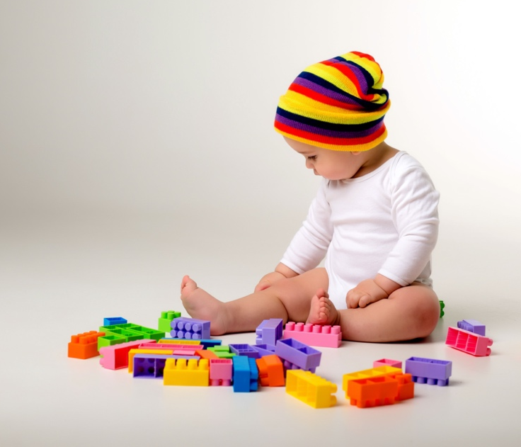
Sighted babies usually develop their hand-eye coordination before they deliberately reach out for an object. Babies who are blind will be guided primarily by what they hear instead of what they see. Hearing as a stimulus, however, is not continuous. That’s where external assistance comes in handy in helping develop auditory-motor coordination. If your child has some vision, you can still help develop their hand-eye coordination at the same time as you stimulate their hearing and sound localization. You are already working on the development of these different types of coordination by presenting them with brightly coloured, high-contrast and sound-producing objects and encouraging them to reach out for them. Whenever possible, have them touch the source of the sound or name what made the sound, describing where it is relative to their body.
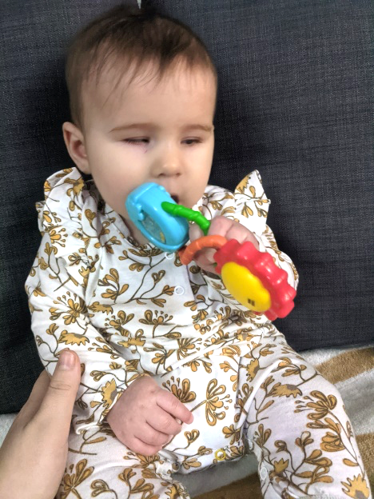
After a feeding or at another moment when they are relaxed, you can sit your child on your lap and bring out enticing objects, e.g., textured, sound-producing or light-producing objects. Start with bigger objects they need to grasp with both hands. Let them bring the objects to their mouth — that’s a big part of the fun! You can eventually work your way down to smaller objects, although not so small as to be a choking hazard. Have them hold the small object in one hand and introduce another object from the same side. Little by little, they will learn to release the first object to grasp the second. Around the age of 6 to 9 months, they will begin transferring the first object to the other hand to then take the new object. The next developmental step involves crossing their arms to grasp the new object in their other hand. These skills may seem fairly rudimentary, but they are vital to acquiring more complex motor abilities later on.

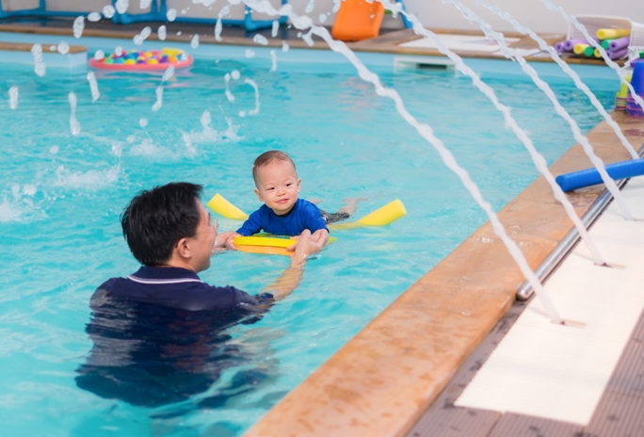
Continue playing in the water to reinforce their body awareness. You can encourage them to kick with their legs or help them fill a container with water and pour it out. Keep naming the parts of their body and their actions. And continue developing their vestibular system with swings, hammocks and baby carriers.
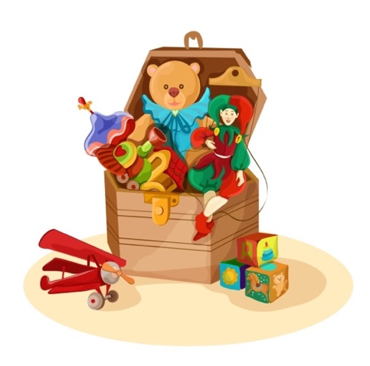
Children with a visual impairment may need more external stimulation than sighted children, but you can also teach them to play by themselves and familiarize themselves with their surroundings on their own. You can start to set up a special play area for them with their favourite toys. The area will change over time as your child’s skills and interests evolve.
Here are a few places you can start:
- Put various toys around a mat or blanket. At a later age, they can be left out on low shelves.
- A padded toy chest filled with toys and stuffed animals of varying sizes, weights and textures is a great tool with endless possibilities. Your child will eventually be able to open the chest and rummage around inside, empty out the contents and fill it back up again, crawl inside and come back out, and even climb on top of it.
- Don’t overload the play area. Be selective in the toys you put out, and rotate as necessary.
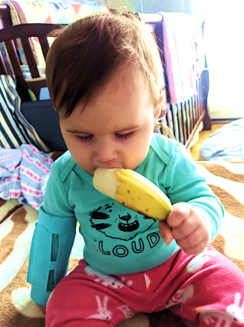
Last but not least, as we mentioned in the last section, keep talking to your child. Tell them what you are doing and what you are going to do. Describe the sounds and smells they are experiencing. Tell them what they are touching and (soon!) tasting.

Quick Reference List
Ideas for Stimulating My Child (3 to 6 Months) *
*The ages provided are approximate. Your child may need stimulation from a different age range. Be sensitive and responsive to their needs, and proceed methodically from one stage to the next, without skipping.
- Lie your child down on their back. Guide them in rotating their legs like a bicycle. Have them hold their feet in their hands.
- Attach objects and toys to something so they stay put when your child lets go of them. You can tie them to the bars of their bed, their high chair, their stroller and other places. You can also use a baby gym or a play arch.
- To help them learn to roll from back to stomach, bring their feet up to their midriff and gently rock their hips from right and left.
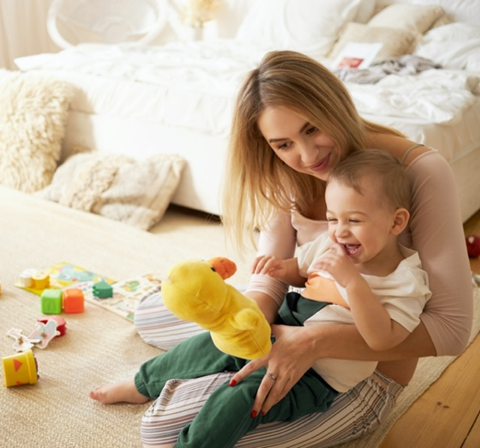
- To help them roll from stomach to back, bring one of their knees toward their chest and rotate their hips.
- Name all the sounds they hear, the odours they smell or the sights they see if they have some vision. Whenever possible, have them touch the object that corresponds to the sensory stimulus.
- After a feeding or during another quiet time, sit your child on your lap and put enticing objects in front of them. Start with bigger objects they’ll need to hold with both hands, and work down to smaller ones (being careful of potential choking hazards).
- Play in the water with your child. Have them kick with their legs and pour water from one container to another.
- Name the parts of their body and their actions as they move.
- Find a round, padded toy box and start filling it up with soft objects of different sizes, weights and textures. It will be used for many things over the years: opening, filling up, emptying out, climbing into and out of, and much more.
- Provide a running commentary for your child: describe their environment, tell them what is making the sounds, smells, lights and other stimuli they experience.
- Keep using your baby carrier, swing and hammock.
Watch video #3 - 3 to 6 Months

6 to 12 Months
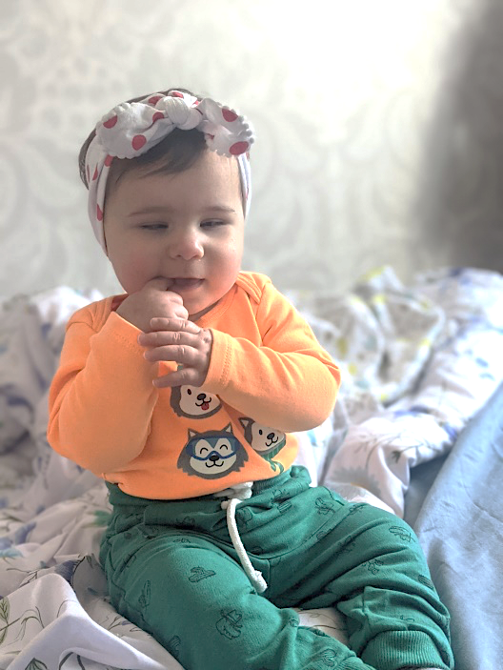

At this stage, it is important to continue working on rolling over (front to back and back to front). Keep putting toys and enticing objects (sounds, lights, bright colours, contrasting patterns and textures) around them. You can refer to the previous sections for further details.
Children generally learn to sit on the ground without support somewhere between this stage and 18 months. If they are still not sitting independently by age 2, we suggest consulting with an occupational therapist, if you aren’t already, for specialized assistance and materials.
A child can learn how to sit in many ways. Sometimes, as they are trying to move forward while on their stomach to reach an object, they may accidentally (and frustratingly!) back up instead. If their leg happens to cross under their body as they are moving backwards, they may end up in a seated position. They may also “fall” into this position if they are on their hands and knees and move their legs toward their chest as they lift an arm to reach for an object. You can use this information to guide your child into a seated position. This will help them move more independently than if you simply prop them up. And when they are sitting on their own, they may try to grasp objects around them, play with them and start crawling again to get to a new location.
When your child is sitting, with or without support, you can help improve their mobility by prompting them to turn their head and rotate their torso. For example, you can put objects that make a sound or are otherwise appealing on either side of them. You could also leave objects around them that they can pick up whenever they like, making sure they are aware that the objects are there.

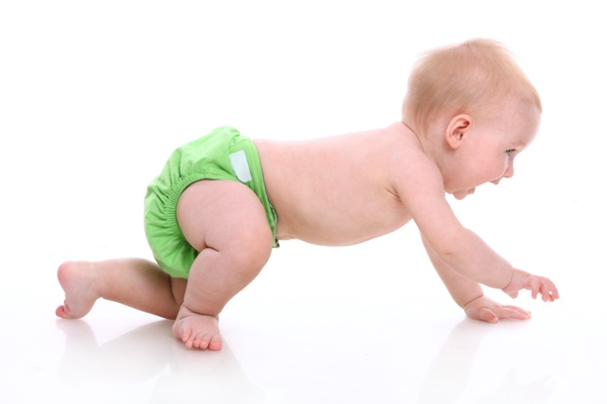
Ideally, a child should crawl before they walk. This will help them acquire other motor skills at a later stage. But many children with a visual impairment do not, and that’s fine. Plenty of sighted children never crawl either. But there are some things you can do to help your child explore this position. When they are on their stomach, guide their legs toward their chest. Note that if your child cannot yet lift up their head using their arms (or, better yet, their hands) from this position, it is still too early for them to start crawling.
If your child can sit up by themselves and handle objectives, you can take advantage of a moment when they have one or two hands on the ground in front of them to rotate their hips and show them how to transfer from a sitting position to their stomach and then on to their hands and knees. Your child may get to this position and then start rocking back and forth. If so, that’s completely natural and part of the transition toward crawling.
Keep naming the parts of your child’s body, using songs like “Head, Shoulders, Knees and Toes.” You can also compare parts of your body to theirs, putting their hands on both as you say the word. Verbally describe all their actions and their movements. This vocabulary will be very convenient later on when they start to play sports.
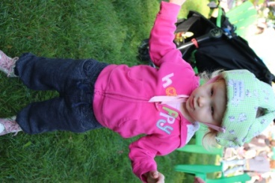
As your child begins to move around, keep your bigger pieces of furniture where they are. That way, your child will be able to rely on the same points of reference to map out your house in their mind. Like for any other child, childproofing is very important at this stage. Make sure anything fragile or dangerous is out of reach. There are also soft padded helmets available to protect your child’s head from injury in the case of a fall.

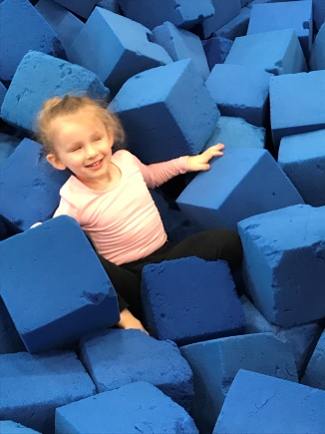
Start to introduce your child to the concepts of throwing and catching. Have them sit between your legs on the ground across from a partner (a parent or older sibling). Roll a jingle ball or brightly coloured or high-contrast ball between you. Help your child determine the direction to send the ball by having the other person call out or clap their hands.
Here are some other accessories and activities that may be of interest at this stage: a ball pit (body awareness) and sledding in the winter, on small slopes with your child sitting between your legs (vestibular system).
If you notice that your child has too much muscle tone (hypertonia), making their limbs stiff and hard to move, or not enough muscle tone (hypotonia), despite your efforts to stimulate physical activity, we recommend that you consult an occupational therapist, physiotherapist or another specialist.

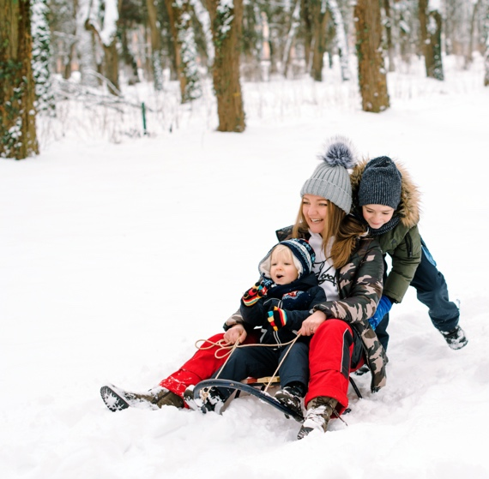

Quick Reference List
Ideas for Stimulating My Child (6 to 12 Months) *
*The ages provided are approximate. Your child may need stimulation from a different age range. Be sensitive and responsive to their needs, and proceed methodically from one stage to the next, without skipping.

- If your child is comfortable lying on their tummy and con support themselves on their arms and hands, you can start helping them transition toward a crawling position by guiding their legs toward their chest or putting your hands under their feet for them to push against.
- If your child can support themselves on all fours, you can encourage them to move forward by talking to them, putting enticing objects in front of them or getting down with them on your hands and knees.
- You can guide them in switching from a crawling to a seated position by turning their hips.
- Sing songs about the parts of the body (“Head, Shoulders, Knees and Toes”).
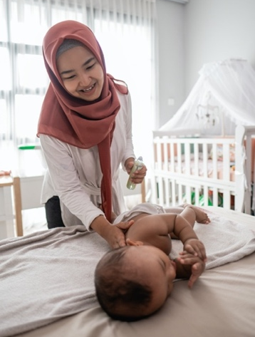
- Don’t make any changes to the layout of your house once your child is crawling. Different pieces of furniture will serve as points of reference to help them find their way around.
- Introduce throwing and catching by sitting across from another family member with your baby between your legs and rolling a jingle ball between you.
- Try a ball pit or sledding in the winter, nestled in a parent’s lap.
- If you think your child is hypertonic or hypotonic, consult with an occupational therapist, physiotherapist, or another specialist.
Watch video #4 - 6 to 12 Months

12 to 18 Months
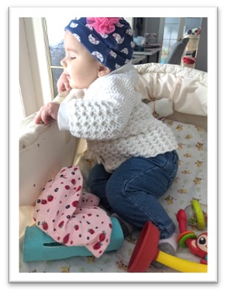
At this stage, your child will likely start to move around, if they aren’t already mobile. This may entail crawling on their hands and knees, scooting around on their bottom or walking upright. Most sighted children start to walk somewhere between 9 and 18 months. For children with a visual impairment, this usually develops a little later, around 16 to 22 months. But in the end, every child progresses at their own pace. Yours may get to this stage earlier or later than their peers.
Until they do start walking, keep encouraging them to crawl. Getting down on all fours with them is a great way to make this happen. You probably haven’t crawled around on the floor for quite some time, but there’s nothing better than experiencing the motion first-hand to be able to guide your child through the process. If your child can hold themselves up on their hands and knees, you can model a crawling motion by gently guiding their limbs forward in order: right hand, left knee, left hand, right knee. When you both get more used to this sequence, you can start moving the hand and opposite knee at the same time.
Cheer them on! Give them a reason to want to go forward, with vocal encouragement or with objects that emit sounds or lights, placed just outside of their reach. If your child tends to walk with their head down, encourage them to lift their chin by holding a flashing object slightly above them or by rubbing the back of their neck.
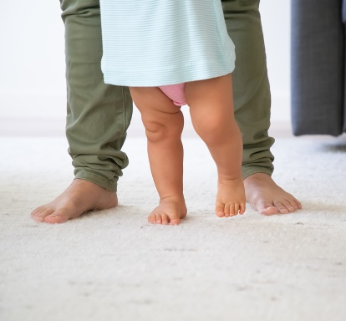
Make your hands-and-knees time together fun! Crawl alongside them or have them crawl under you. You can also have them crawl or walk between your legs while you’re standing.
Here are a few ideas for games you can play:

- Pretend to be different animals.
- Play with toy cars or other rolling toys.
- Put a rimmed basket about 1 metre (3 feet) away from your child and place objects in there that will pique their curiosity, especially toys that make interesting sounds. Crawl over to the basket yourself and “discover” the contents. Shake the toys to activate the sounds and get your child’s attention.
- Place textured surfaces on the ground to provide a tactile stimulus for your child. A bathmat or rugs of varying softness are ideal. Just make sure they are anti-slip.
- Let your child move forward a little and then hold them back by gently grasping them at the waist. They’ll probably start to giggle and try even harder to move when you let go!
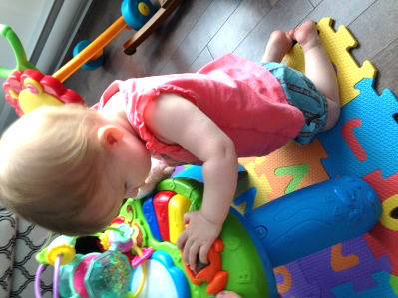
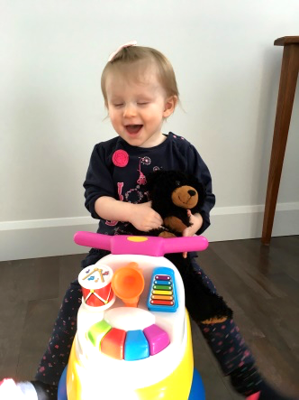
To help teach your child to stand and stay standing, you might want to consider a musical table, with buttons that play different sounds, or another kind of a toy that acts as an incentive.
This may also be a good time to introduce a toy they can sit on and push forward with their legs. They can then explore the house by bumping into the various objects around them. (Careful of any stairs!)
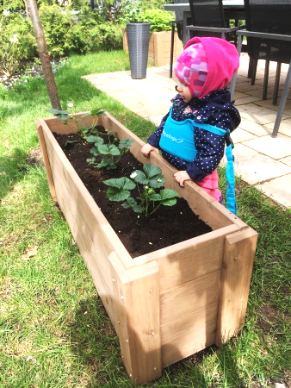
You can use a variety of techniques to show your child what it feels like to walk upright. Hold their hands and put their feet on top of your feet as you walk. Or hold them by the hips and guide them forward. You can also try an assistive device known as “Walking Wings” (see the picture below). Practise often but only in short increments. Once your child is walking in earnest, expose them to all sorts of textured surfaces, both in bare feet and in shoes: wood, tile, carpet, sand, gravel, grass and more. The more confident they become, the more you can challenge them on surfaces that are bouncy (e.g., a blow-up mattress), sloped or uneven. Test the surface out yourself beforehand by walking on it with your eyes closed to determine how difficult it is to negotiate. Walking in the water may also help your child with their gait and balance.
In fact, water play can very beneficial in many ways. You can get your child to kick their legs and have them float on their belly and their back, supported, all of which are key pre-swimming skills.

Continue naming (and singing!) the parts of their body as you touch them and start using directional terms like left, right, up, down, ahead, behind, on, under, etc. This vocabulary of movement will be very helpful in learning sports and other physical activities and in helping them orient themselves in space.
Pay special attention to your child’s stance and posture. Some children with a visual impairment tend to stand with their legs splayed outward in an attempt to reinforce their stability. But this may become a habit and interfere later on when they’re learning to run. Other children tend to shuffle as they walk, also out of a desire for balance. But this can be detrimental over the longer term as well. If you notice either pattern, we suggest you consult with an occupational or physical therapist for remedial tips and strategies.
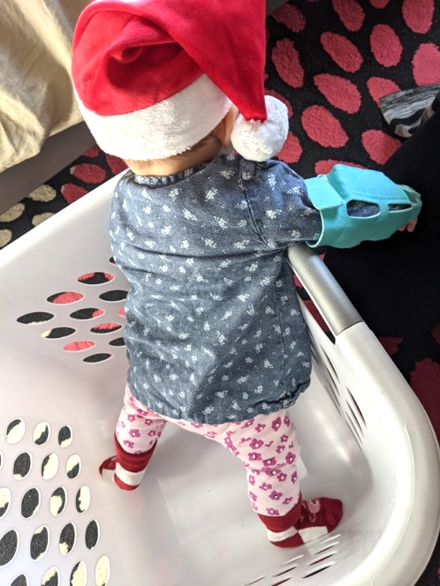
One of our members shared an idea with us that helped her daughter overcome her fears, which often arise around age 3, as children grow and develop. She had taken lots of videos of her daughter engaging in a range of physical activities when she was younger. When these videos were played back to her daughter in response to her anxiety, she heard her younger herself having fun and felt reassured.

Quick Reference List
Ideas for Stimulating My Child (12 to 18 Months) *
*The ages provided are approximate. Your child may need stimulation from a different age range. Be sensitive and responsive to their needs, and proceed methodically from one stage to the next, without skipping.
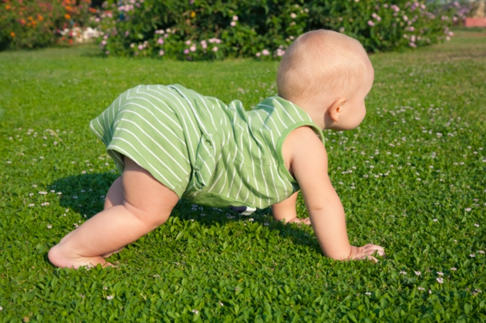
- Encourage them to crawl.
- Gently guide their hands and knees in a crawling motion.
- Use enticing objects or vocal encouragements.
- If your child tends to keep their head down as they move forward, encourage them to lift it by holding objects slightly above them or by gently rubbing the back of their neck.
- Make crawling time fun time!
    - Get down on all fours with them.
    - Make a bridge with your legs and get them to crawl underneath.
    - Pretend to be different animals together.
    - Play with cars or other rolling objects.
    - But a surprise basket in front of them filled with interesting objects and start by “discovering” the surprises yourself.
    - Place different anti-slip rugs and other textured surfaces on the ground for them to explore.
    - Let your child start crawling and then catch them by the waist until they wriggle to be let go.
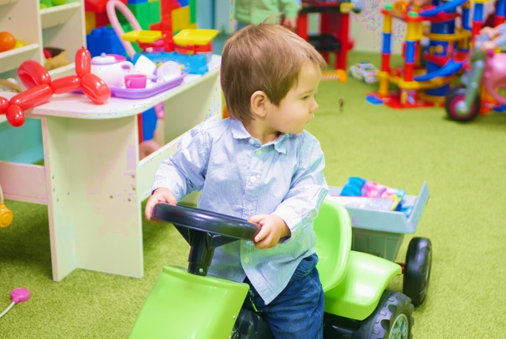
- A few ideas:
  - Introduce a musical table or another toy that rewards a child for pulling themselves into a standing position.
  - Place an interesting object on the seat of a sofa.
  - Try a “sit and scoot” toy.

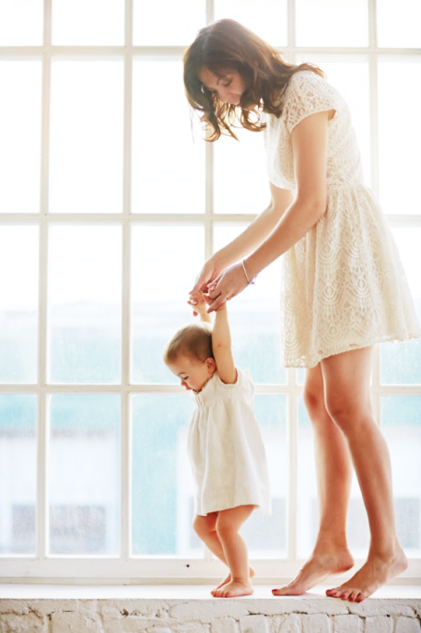
- Practise walking for short periods so they can get used to being in an upright position:
- Put your child’s feet on top of your feet and hold their hands as you move one leg forward at a time.
- A walking harness (“Walking Wings”) may be something you want to try out.
- Expose your child to all sorts of ground surfaces: lawn, sand, concrete, wood, carpet, etc. Have fun with them exploring new surfaces: inflatables, slopes, uneven ground, water, etc.
- Keep playing in the water: let your child kick and float on their front and back with an adult’s help.
- Keep naming the parts of the body and actions, and introduce directional terms like right, left, up and down.
- Watch your child’s gait and posture, and consult a specialist if you notice they tend to keep their legs spread apart or shuffle their feet as they walk.
- Parent tip: take videos of your child engaging in physical activity to remind them what they are capable of if they start to develop certain fears (usually around age 3).

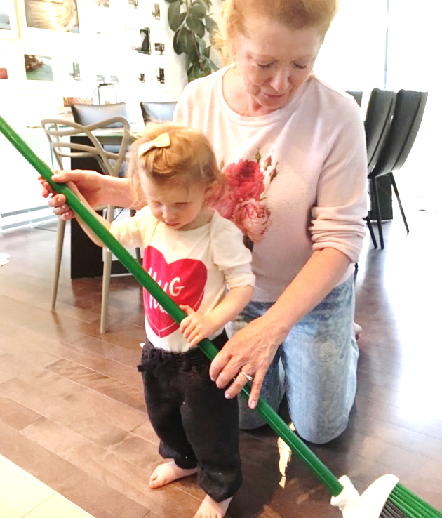
Watch video #5 - 12 to 18 Months

18 Months to 2 Years

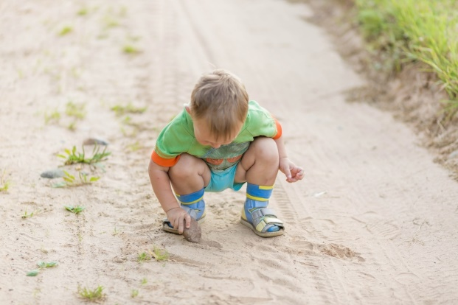
You’ll definitely want to keep up the good work in helping your child acquire or strengthen their walking skills. You can make a game out of carrying selected objects from point A to point B. Try doing this with large, lightweight objects that they need to hold in both hands, then transition to smaller items they can carry in one hand, and then two objects, one for each hand.
To have them practise the transition from a standing position to a squatting position, you can play at picking up an object from the floor and bringing it back up again. Do this by hiding one or more objects that make a sound and telling your child to go get them and bring them back to you. You might also want to lay a small ladder on the ground and have your child walk through the rungs. Lifting their feet will encourage hip rotation and direct their forward movement. You can also play a “choo-choo” game, with one person behind another, hands on shoulders or the waist depending on respective heights. As the “train” moves forward, each “car” has to walk a certain way: on their tiptoes, on their heels, on their knees, crouching over, moving sideways, backing up, using giant and baby steps, and so forth.
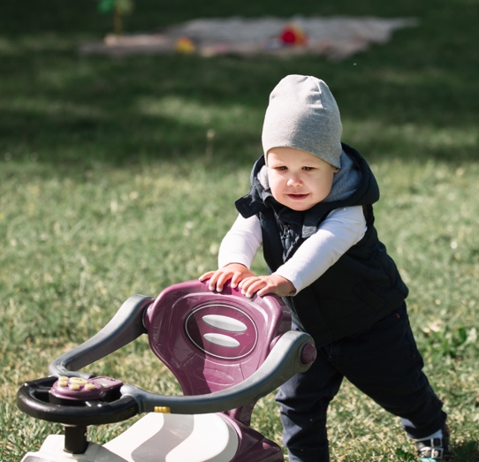
If your child tends to bend their head down as they walk, try this balancing trick: put a beanbag or another object with a little weight to it on top of their head and ask them how long they can walk without it falling off.
In the winter, to get ready to walk in the snow, you can dress your child up in their snowsuit and boots, and give them an obstacle course to navigate. Outside, an assistive device like Walking Wings may be helpful.
Once your child is walking independently, you can introduce push toys like toy lawnmowers and shopping carts. This will help them develop their ability to get around on their own. Any collisions will be absorbed by the object in question, which will give them an extra boost of confidence and help them increase their speed.

Speed can be an important aspect, especially later in life, when crossing a busy street with a traffic light, for example. Push toys are also a great way to prep for using a cane, if your child needs one. As for when to introduce an actual cane, check with your orientation and mobility specialist about timing and strategy.
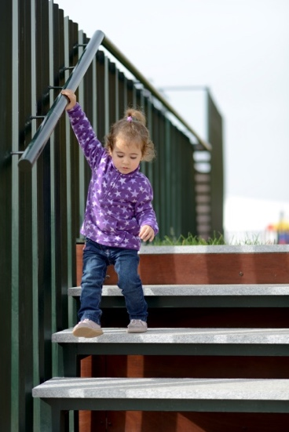
When practising stairs, proceed incrementally and logically:
- Have them start on all fours in both directions (up and down).

- Then have them climb the stairs upright, two feet on each step, and go down backwards on their hands and knees.

- Later, they can ascend and descend standing up, two feet on each step, holding an adult’s hand to start, and then using a handrail.

- Finally, they can do both directions while alternating feet. Most sighted children achieve this milestone somewhere between the ages of 3 and 4, so there’s lots of time!
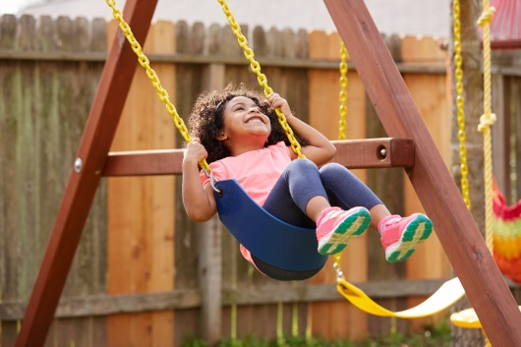
If you haven’t yet introduced your child to the game modules at your local park, now might be a good time. If they start early, they will be more familiar with their surroundings by the time they express a desire to play in the park with other children. Your child will probably need your support and encouragement in the beginning to explore their new surroundings: climbing ladders, sliding down slides, going back and forth on the swings, and so on. The key is to take things slow and step by step. For example, you may want to begin sliding at the bottom third of the slide rather than the top. Starting out, you’ll want to be very hands-on, but you can gradually let them try things on their own as they become more capable and confident. Remember that outdoor play is critical to a child’s development. The more time a child spends outdoors, the more active they tend to be.
You may have to make a few adjustments based on your child’s needs. For instance, if your child has difficulty tolerating light, sunglasses are a must. Or you may wish to select a park with lots of trees for shade or go in the late afternoon or early evening when the sun isn’t so bright.

At home, you can create a fun challenge with an indoor obstacle course: climb under a table, walk on a cushion, straddle a toy, etc. Use verbal cues and sounds to guide them, and take them by the hand as needed.
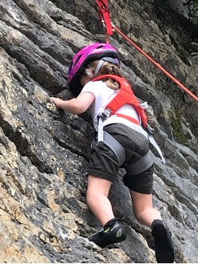
Climbing and running are two activities that parents of children with a visual impairment tend to dread. Remember: it is important for your child to explore their potential to the fullest and develop every physical ability they can. It is important to avoid transferring your own anxiety to them. Take things one step at a time. Start with smaller challenges and constant supervision, and gradually let them take over. This is key to developing their self-assurance and their ability to know and test their limits.
If your child has climbed up somewhere and is nervous about getting back down, we suggest you let them figure it out on their own, providing them with verbal cues or guiding their hands and feet. Try not to pick them up and do it for them, unless there’s no other option. And be sure to teach them how to slide down, feet first, off a couch to avoid getting hurt.
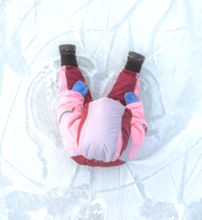
Ongoing water play is suggested to enhance body awareness and balance. Swings and slides are also highly recommended. You may also want to explore surfaces that are unstable (gravel, sand, etc.) or slippery (ice). When introducing your child to ice, you can start by sitting down on the surface of an ice rink with them, have them touch it and perhaps even crawl on it to gauge how slippery it is. Obviously, you’ll have to choose a time when nobody else is using the rink, or find a quiet corner on your own where there is no risk of colliding with anyone else.
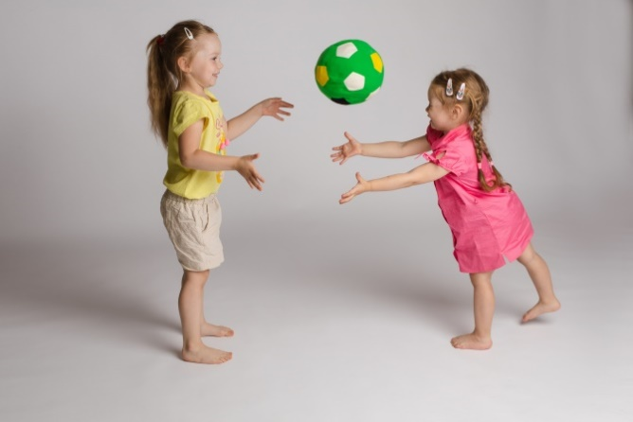
If you have already been rolling a ball back and forth on the ground with your child, you can take this one step further and start doing it in the air to develop their throwing and catching skills. Start out with a big ball in close proximity to your child, using both hands. Then slowly increase the distance between you and decrease the size of the ball. Begin with underhand throwing and subsequently introduce overhand. To help them assimilate the movement, you can have them touch your arm while you are throwing, or put your hand over theirs and guide them through the motion. Repeat the sequence yourself slowly so they can understand how it works. Help your child fine-tine their ability to throw in the right direction by calling out and clapping your hands. You can use audible balls or brightly coloured or patterned balls that stand out from their surroundings, depending on your child’s strengths and abilities. Velcro toss and catch sets are a particular favourite among children with a visual impairment.
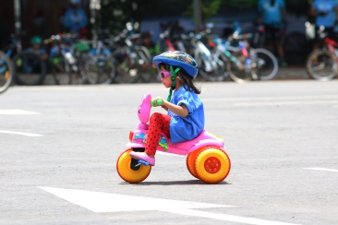
If you and your child are ready, you may want to consider a balance bike and/or a tricycle. We suggest a Big Wheel–style model to start out. The lower centre of gravity makes it easier for a child to keep their balance. Traditional tricycles can also do the trick if that’s what you have. Start by introducing the child to the bike by touching it and/or looking at it closely. Explain what the different parts are and do, where the feet go, and how to make it go forward, turn and so forth. Then find a safe, obstacle-free space and let them give it a whirl! You can use a rope or a flexible rod to gently push or pull them to start. Wrap Velcro ties around their feet so they stay on the pedals. And don’t forget their helmet! For children with a visual impairment, solo bike rides may not be in the cards, but learning how to pedal is an important skill for their overall mobility and the muscle tone in their legs. A tandem bike may be an option worth exploring when they’re older and they have already learned the basics of bike riding.
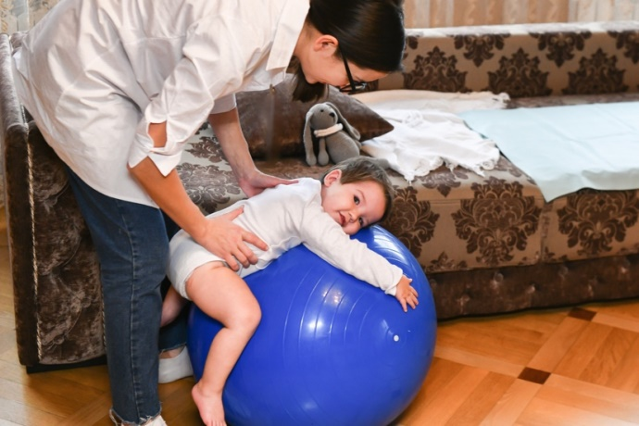
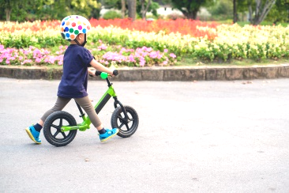
You may want to help your toddler practise falling at this stage and reinforce the protective response of putting out an arm to break their fall. Start with a therapy ball or a Swiss exercise ball (about 40 cm or 15’’ in diameter). Have your child lie on their stomach on top of the ball and then roll the ball forward and backward. You can also run through the sequence of movements involved in a fall: starting from a seated position, then moving to a kneeling position and finally a standing position, so they are ready when a tumble happens in real life.
The more opportunity your child has to practise their physical skills, the better prepared they will be to embrace an active lifestyle for years to come. It’s about setting the wheels in motion. A child with strong fundamental movement skills will find it easier to expand their repertoire of physical activities, will have confidence in themselves and will be more inclined to exercise and play sports.

This can be said of all children, naturally, but children with a disability may need an extra nudge in this direction to fully develop their motor skills and achieve their potential.

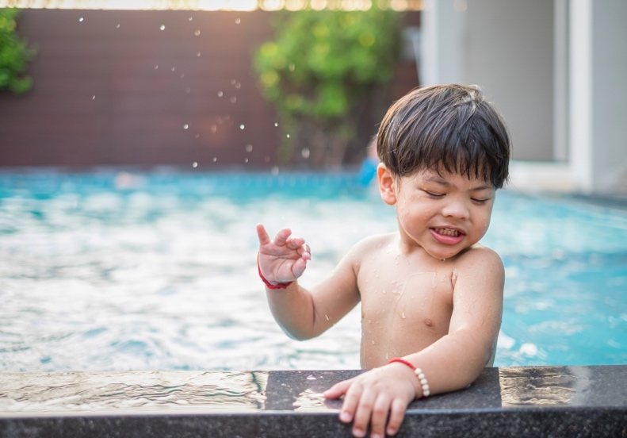

Quick Reference List
Ideas for Stimulating My Child (18 to 24 Months) *
*The ages provided are approximate. Your child may need stimulation from a different age range. Be sensitive and responsive to their needs, and proceed methodically from one stage to the next, without skipping.
- Games and activities to get your child walking:
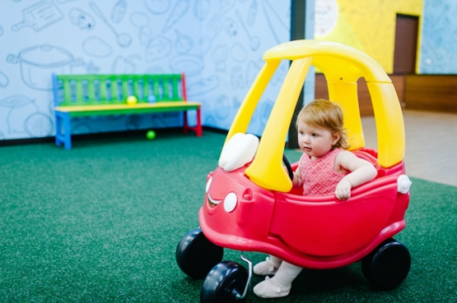
  - Transfer objects from one basket to another.
  - Hide sound-making objects and make a game out of finding them.
  - Play the “choo-choo” game: line up like train cars, one person in front of the other, and walk the same way (on tiptoe, on the heel, giant steps, baby steps, etc.).
  - Lay a ladder on the ground and have your child walk over and through the rungs.
  - Have your child walk with a beanbag balanced on top of their head.
  - Introduce walking push toys.
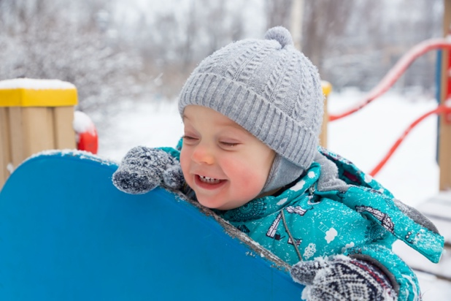
- Teach your children how to navigate stairs. Start on all fours, up and down, and gradually add on new skills. A detailed description is provided in the main section.
- Introduce your child to play modules at your local park (swing sets, slides, etc.) and make it point to play outside as often as you can.
- Have them touch and explore different types of surfaces: grass, concrete, gravel, water, snow, ice, etc.
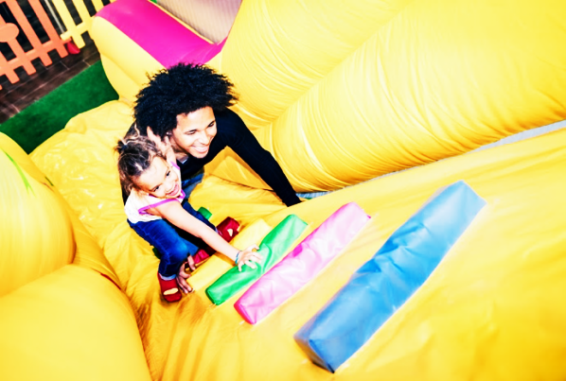
- Set up obstacle courses at home or in your yard. As winter approaches, have them go through the course in a snowsuit and boots to prepare them for walking in the snow.
- Encourage your child to climb wherever and whenever it is safe for them to do so. Show them how to get down on their own. Provide verbal cues or manual support, but avoid picking them up yourself.
- Practise throwing and catching together, starting with a big, lightweight ball and standing in close proximity.
- You may want to introduce a balance bike and/or tricycle at this stage, depending on what’s available to you and what your child prefers.
- Teach your child how to fall: start by lying them down on a therapy ball and roll it forward and backward. Then have them go through the sequence of motions of a fall, starting with the knees.
Watch video #6 - 18 Months – 2 years

2 to 3 Years

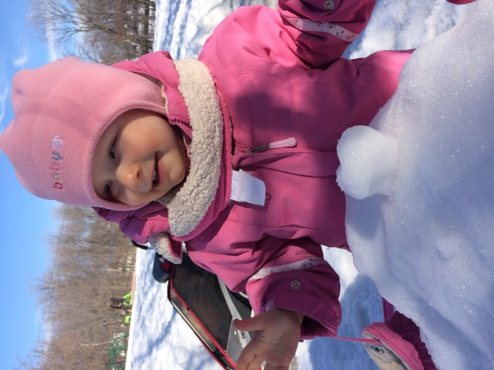
This is the stage at which your child will really start to show interest in exploring activities that combine physical agility with the rudiments of game play.
There are plenty of games you can play together that meet both objectives. Here are just a few:

- Simon says: The child has to do whatever the person playing Simon tells them to do, using the formula “Simon says…” If Simon gives a differently phrased instruction, the child must disregard it. (You can watch the game in action in the video listed in the references.) Sample commands include touch your toes, touch your knees, touch your shoulders, stomp like a giant, walk on your tiptoes, step to the side, take a step backwards, hop like a bunny, leap like a frog, run to the designated spot (audio cue), march like a soldier, dance like a ballerina, pretend to be a robot, etc. Select the commands that match your child’s abilities and interests.

- Made-Up Stories: Improvise a story where key words are linked to certain actions. For example, every time you say the word “bunny” in the story, your child has to hop like a bunny. Or in a story where a mouse is hiding from a cat, your child has to scamper like a mouse as the cat approaches. You can work games like these into your day-to-day routine, like going to daycare or picking up something from the store.

- Red Light, Green Light: The leader calls out the traffic light colour: green to run, yellow to walk, red to stand still.

- Animal Make-Believe: Walk and make sounds like the animals picked by the leader.

- Obstacle course: Add more elements and make them more challenging. (See the previous stage for ideas.)

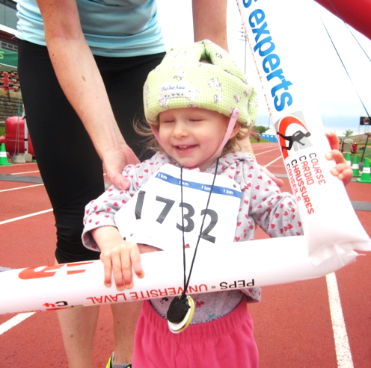
Keep using games that explore different ways of walking. You may also want to introduce your child to running at this stage.

The idea of running can be a source of anxiety for parents of a child with a visual impairment, who understandably worry that they will get hurt. There is admittedly a certain risk involved, but you can introduce the activity gradually and with supervision to keep your child safe as they learn this important life skill and develop their independence.
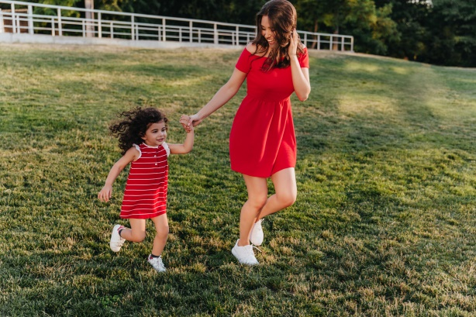
Not only is running a great way for young children to expend the almost boundless energy they have, but it is also key to increasing body awareness. It strengthens leg muscles and is essential to many physical activities and sports. Running also comes in handy in day-to-day situations, like taking the bus or catching up with a friend. Last but certainly not least: running and jumping give children a sense of freedom and confidence in their own abilities.
To start, let’s take a closer look at the mechanics of running. Your child will need to keep their head straight and their elbows bent and close to their chest. Their legs and feet need to be pointing forward, without straying to the side. At this point, you can simply give your child oral instructions about how to proceed, without being too rigid or expecting them to adjust their gait right away. It will take time and practice, but they will get there!
The easiest place to practise running is a flat and open stretch of land, like a baseball or soccer field. To get started, you can take your child by the hand or pair them up with a peer. As they become more proficient, you can replace the hand with a short rope, which you can lengthen over time.
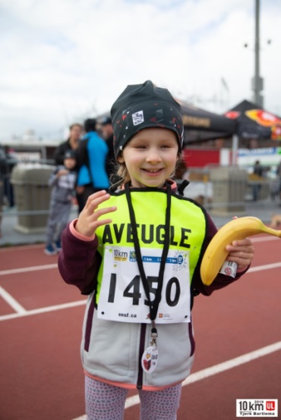
You can play tag or a version of Marco Polo, where you make a sound with something like a maraca and have your child try to catch you. As your child becomes more comfortable running, you can create a running track in your backyard, sectioned off with string. You can tie on small bells where they need to do something specific, such as shift directions.
It is important at this point to impress upon your child that they should run only when they are in a safe environment. You can instruct them, for example, to feel the surface they are on and run only if it’s grass. That’s the first step in making them more aware of their surroundings (near a street with busy traffic, in a park where there are children playing, etc.) and adjusting their behaviour accordingly.

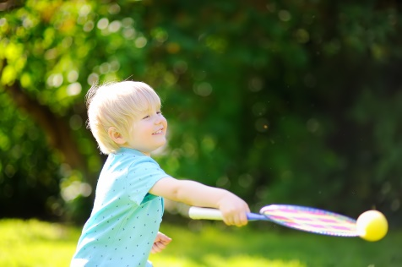
In addition to continuing to develop throwing and catching skills, you may want to introduce the concepts of striking an object with bat or a racket and kicking a ball.
To teach them how to strike an object, use something oversized to start. If your child has some vision, a brightly coloured badminton birdie may work. Again, Velcro toss and catch sets are great for this.
When it comes to kicking, you can take similar approach by demonstrating each step of the movement in slow motion. You can have your child watch closely or touch your legs while you do. Then have your child mimic you and use your hands to gently correct their movement where required. Have them try with both the left and right foot, and use their feet to stop an oncoming ball. You will need a brightly coloured, high-contrast or audible ball for this.

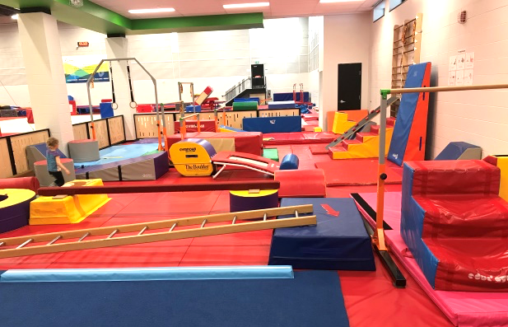
Your child is at an age where you can enrol them in group activities at a local community centre. Many gymnastics, physical literacy (e.g., Karibou, Pirouette et Cabriole or Active Start) and dance programs are a wonderful solution for improving body awareness and often offer a parent/child option.

Introduce your child to as wide a range of sports and activities as possible by letting them explore the gear and accessories that come with them. Don’t rule anything out. Let them try whatever appeals to them and focus on their progress, both in terms of difficulty and the level of support and supervision. Take advantage of every opportunity to get moving and get outdoors!

Here are a handful of ideas for exercises and activities that may strike a chord with your child:
- Sit on an “invisible chair” with them using a vertical surface for support (an exercise otherwise known as a wall sit or a chair squat) while you play pattycake.
- Put beads into a balloon and blow it up (so you can hear the beads rolling around inside). Then see how long you can keep the balloon up in the air.
- Make a little “bunny hill” in your backyard or the park where you can introduce your child to the basics of downhill skiing.
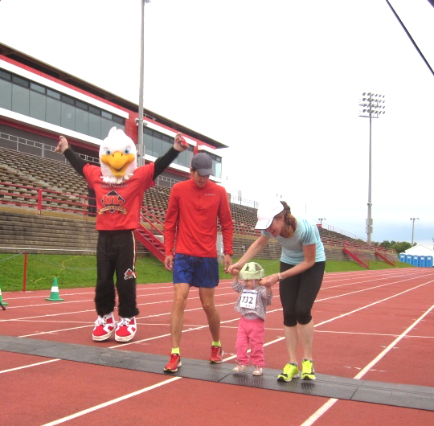
- Have your child walk up and down a hill. Then have them run!
- Start them on a balance bike and/or tricycle if you haven’t already.
But most of all: have fun together!

Quick Reference List
Ideas for Stimulating My Child (2 to 3 Years) *
*The ages provided are approximate. Your child may need stimulation from a different age range. Be sensitive and responsive to their needs, and proceed methodically from one stage to the next, without skipping.
- Introduce games with simple rules (Simon Says, Made-Up Stories, Red Light Green Light, Animal Make-Believe, etc.).
- Practise running with your child.
- Make sure they have good running posture (see the main section for details)
- Start by running hand in hand with your child, or have them do it with another child.
- On a flat, open stretch of land (baseball or soccer field), play tag using the sound of your voice or another running game.
- Teach your child to run only when it is safe to do so by helping them identify ambient sounds and checking the type of surface (e.g., grass).
- Keep practising throwing and catching, and introduce striking (with a large object) and kicking.
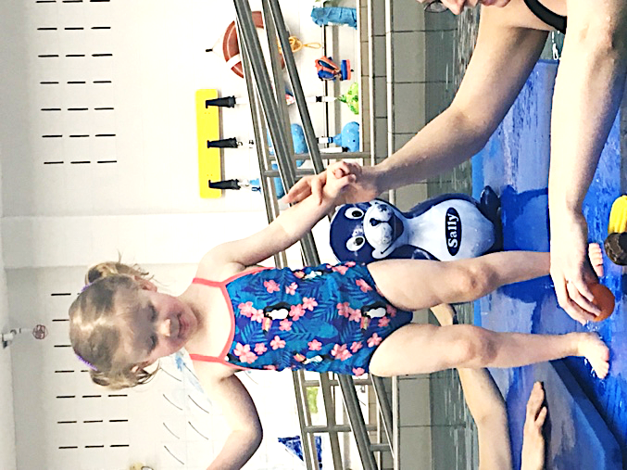
- You may want to explore organized parent/child activities at a local community centre.
- Do chair squats and play pattycake together (it’s a good workout for both of you!).
- Blow up a balloon and put a few beads inside. Then see how long you can keep the balloon up in the air.
- Make a “bunny hill” in your backyard or the local park to teach your child the basics of downhill skiing.
- Have your child walk up and down a hill. Then have them do the same thing, only running!
- Start them on a balance bike and/or tricycle if you haven’t already.
- Let your child explore as wide a range of sports gear and accessories as possible so they are exposed to a variety of activities at an early age.
Watch video #7 - 2 to 3 years

3 to 4 Years

At this stage, keep helping your child work on their walking, running, catching, throwing, kicking, crawling, climbing, swimming and other skills, individually but also in combination.
It is around this age that many children learn to jump. However, if your child has stiff muscles (hypertonia), you are advised to consult with a physiotherapist first to make sure they have enough strength in their legs. As an example, your child should be able to climb a set of stairs one foot at a time before they learn how to jump.
To help your child understand what is involved in jumping, especially if they are blind, start by jumping yourself and let your child touch your legs or put their hands around your waist. You can also ask another child to jump while your child rests their hands on their companion’s shoulders.
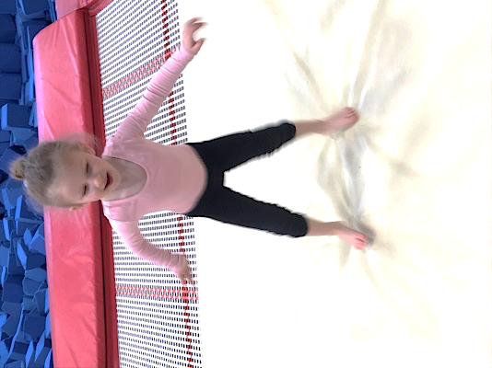
To convey what it feels like to jump to your child, you may want to start on a trampoline. Get your child to stand on the trampoline mat, while holding on to a bar, a wall or an adult’s hand, and bend their knees. They will feel the movement in the mat. You can also get them to jump from a small footstool to the floor, putting their hand against the wall for support. And you can ask them to bend their knees and jump over a light-emitting, high-contrast, brightly coloured or textured object placed on the ground. They can use their arms to propel themselves forward. If they need help, you can hold them by the hips and guide their movement. But be sure to let them try on their own as quickly as possible!
When they have mastered the simple two-leg jump, you can instruct them to try one-leg jumps with alternate legs and then hops (multiple jumps with the same leg). Later, you can have them jump from side to side and make the instructions more complex: jump high and low, near and far, and vary the types of movement. You can work jumps, hops and leaps into games and races. They can pretend to be a kangaroo, rabbit or frog during Animal Make-Believe. During Simon Says, “Simon” can direct them to jump as far as they can. And you can put hula hoops on the ground and have your child leap from one to the next.

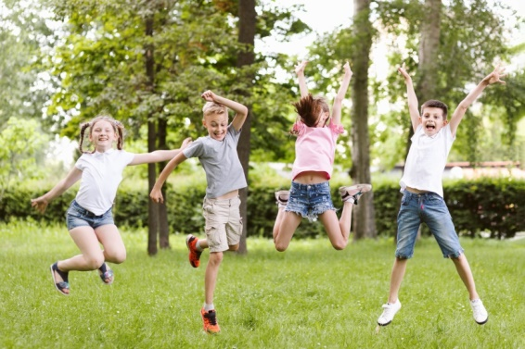
Jumping isn’t exactly a requisite life skill, but it is something many children love to do. It helps them burn off extra energy and is essential to several sports. It can also come in handy in everyday life, to avoid a puddle or a patch of mud, for example. It’s also excellent for proprioception and the vestibular system.
Keep going to the park on a regular basis if you can. Your child will really be enjoying playtime with friends at this point as they graduate from parallel play into associate play. You can arrange playdates at home to strengthen their bonds with their peers.
You can make your games more complex, too. Add more rules to Simon Says, for example, hold a Three-Legged Race or play Follow the Leader through an obstacle course set up with auditory or tactile markers. In the winter, you can build a snow fort, have a snowball fight or make a snowman, or go sledding, cross-country skiing, snowshoeing or hiking.
Private or semi-private swimming classes can be started at this age, in a small pool if possible. The noise of a public pool can be very distracting for a child with a visual impairment.
In terms of biking, you can continue with the tricycle and/or balance bike, or advance to a two-wheeler with training wheels if your child is ready for it. You can help them improve their balance by coming up with fun challenges like passing a ball over to someone else while standing on one foot.
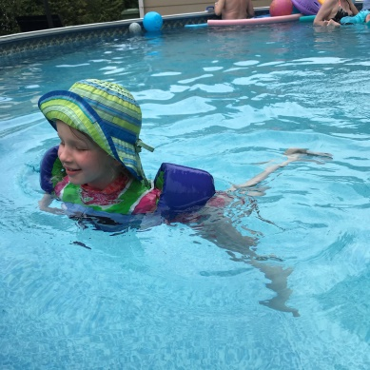

You can gradually help your child recognize what their preferred method of learning is (e.g., verbal instructions, touch, trial and error, listening) and articulate their needs in this regard.
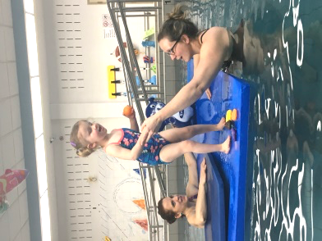
For example, you can give them choices: Would you rather me show you this movement myself, tell you how to do it or use my hands to guide you?
They will already have a sense of what works best for them. They may have started to ask you to move closer or position yourself so they can see you better. Or they may ask if they can touch you or get help in another way. The more comfortable they are expressing their needs with you, the easier it will be to do the same with others.

Quick Reference List
Ideas for Stimulating My Child (3 to 4 Years) *
*The ages provided are approximate. Your child may need stimulation from a different age range. Be sensitive and responsive to their needs, and proceed methodically from one stage to the next, without skipping.

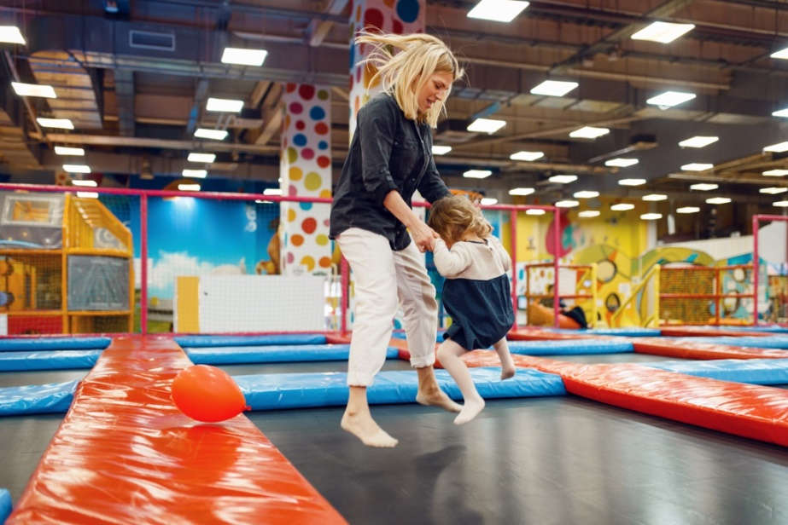
- If your child doesn’t have high muscle tone (hypertonia) and can climb a set of stairs one foot at a time, you can gradually introduce them to jumping:
- Jump yourself and let your child observe you or touch you as you do.
- Show them what jumping feels like by having them stand on a trampoline mat and bend their knees.
- Have them jump from a small footstool to the floor.
- Have them jump over a brightly coloured, high-contrast, light-emitting or textured object.
- Once they have mastered the simple jump, you can move onto hops, skips, side-to-side jumps and leaps, and have them vary the type, height and length.
- Make jumping part of other games: Simon Says, Animal Make-Believe, obstacle course, etc.
- Make the games you play more and more complex, with increasingly detailed rules: Simon Says, Three-Legged Race, Follow the Leader, obstacle courses with auditory or tactile markers, and more.
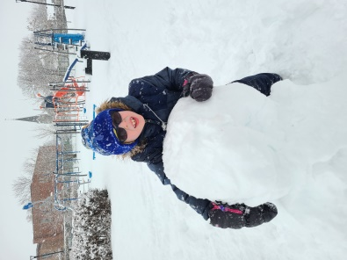
- If you’d like to enrol your child in swimming lessons, this is a good time to start. If possible, opt for private or semi-private lessons in a small pool.
- Encourage your child to identify and express techniques and approaches that help them learn.
- Other activities you may want to explore: build a snow fort, have a snowball fight, build a snowman, go sledding, cross-country skiing, snowshoeing or hiking.
Watch video #8 - 3 to 4 years

4 to 5 Years

In addition to continuing to work on the skills that you have already introduced to your child (walking, running, jumping, throwing, catching, crawling, climbing, swimming, etc.), you can start exploring an expanded range of physical activities as a family.
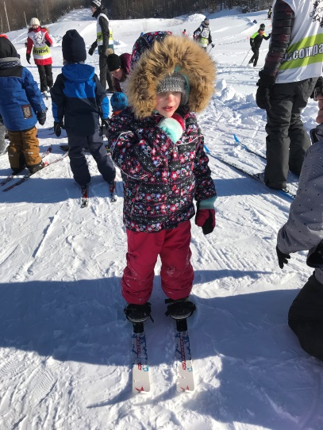
It is also around this stage that your child may want to take part in a group activity, if they haven’t already had that opportunity. You don’t need to enrol them in structured classes, although this can be helpful in developing their social and motor skills. It’s your call to determine the most beneficial approach based on their needs. If cost is an issue, many community centres have programs in place for low-income families to provide an affordable lineup of activities.
In this section, we will be taking a closer look at how to integrate your child into activities in the community. The first step is to select an activity they will enjoy. You can start by asking other parents of children with a visual impairment for suggestions. This may be a good time to join an organization like the AQPEHV (Association québécoise des parents d’enfants handicapés visuels) in Quebec, the OPVIC (Ontario Parents of Visually Impaired Children) in Ontario, if you’re not already a member. One of the purposes of organizations like these is to provide affordable and accessible activities for everyone.
Private or semi-private lessons (with siblings, for example) may be a good idea, depending on the kind of activity, your child’s needs and the budget at your disposal.
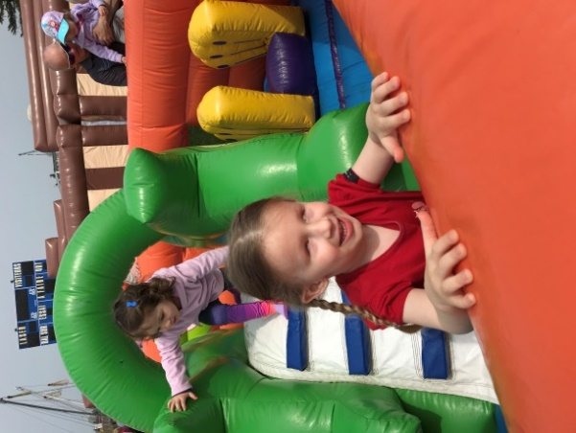
Feel free to contact us if you need help or guidance in integrating your child into a community activity. ASAQ offers a budget-friendly course for activity leaders who are called on to work with people with a visual impairment. We can also do some research to find suitable clubs, centres and schools that have experience in working with participants who are visually impaired.

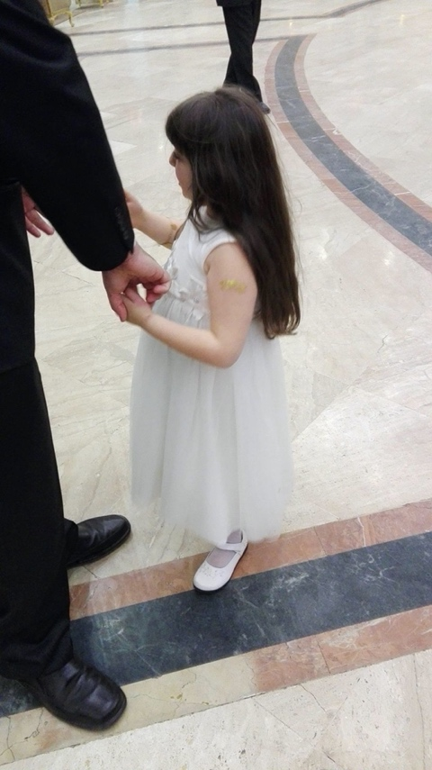
Some activities that are particularly popular with children who have a visual impairment are swimming, dancing, horseback riding (or equine-assisted therapy), climbing (starting with bouldering), running, track and field, judo, wrestling, gymnastics, goalball, adapted soccer (five-a-side soccer or blind soccer), cross-country skiing, downhill skiing (with a guide), hiking, snowshoeing, canoeing, kayaking, ice skating and roller skating. Learning how to skate will be easier at non-peak rink times. The last activities on this list are very family-friendly and don’t need any kind of formal structure.
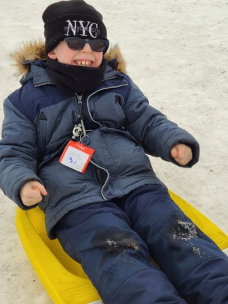
Ideally, children should be exposed to as wide a variety of activities as possible through until the age of 12, with a mix of structured and unstructured activities and lots of time for free play. Remember to keep in mind any other health conditions and precautions when making a selection (e.g., activities where there is a reduce risk of falls or impacts to the head).
Once the choice is made, it is important to help your child prepare. Talk to them about the activity beforehand and describe what will happen. Outline any rules they will have to heed. If possible, visit where it will take place a few days in advance and meet the instructor, and perhaps even sit in on a class. If there is any gear or equipment involved, let your child familiarize themselves with it if they can. As needed, brief the instructor on any safety considerations or measures that might be helpful to your child’s learning (e.g., put them at the front of the group so they can be close to the instructor).
The presence of a parent (or shadow) will likely be required at first. Gradually, the child will become more independent as they get used to the environment and as the instructor becomes more comfortable in adapting their approach.
Keep in mind that you will always have a certain amount of education to do with any instructors or activity leaders who work with your child. The same applies to their school, especially when it comes to physical education classes and extracurricular activities. Incidentally, since your child will soon be starting school, you may want to head over to the school yard on weekends, if you can. That will give your child the opportunity to acquaint themselves with the new environment so they will be ready for their first recess periods.
When difficulties arise, talk to your child and involve them in the search for solutions. Over the long run, it will help them be their own best advocate and give them the vocabulary to identify and request any adaptations they may need.
Here are a few ideas of the kind of accommodations that may be useful during community activities, based on comments we have received from other parents:
- Involve the other participants in the class in guiding the child and describing what is going on.
- A volunteer (e.g., an older child belonging to the club) can buddy up with your child during lessons, activities and/or outings.
- Dance, skating and other similar instructors may opt to wear brightly coloured gloves and/or items like skate wraps so they stand out.
- During swimming lessons for children with low vision, use a large object in a contrasting colour to mark the end of a lane. Children who are blind will need a “tapper,” i.e., a guide with a long pole to indicate when to turn around. This technique requires a certain level of maturity and a lot of practice. It is generally reserved for school-aged children.

Quick Reference List
Ideas for Stimulating My Child (4 to 5 Years) *
*The ages provided are approximate. Your child may need stimulation from a different age range. Be sensitive and responsive to their needs, and proceed methodically from one stage to the next, without skipping.
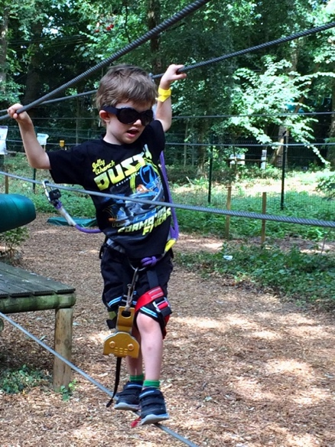
- You can look into signing your child up for a group activity through a community centre, taking their needs and interests into account. See the main section for further details.
- Some activities that tend to be popular with children with a visual impairment include swimming, dancing, horseback riding (or equine-assisted therapy), climbing (starting with bouldering), running, track and field, judo, wrestling, gymnastics, goalball, adapted soccer, cross-country skiing, downhill skiing (with a guide), hiking, snowshoeing, canoeing, kayaking, ice skating and roller skating.
- Bear in mind that, at this age, your child needs to be exposed to a wide range of activities. This will continue to be the case until the end of their preteen years.
- When your child comes up against a challenge, involve them in seeking out solutions. They will feel empowered and learn how to ask for the accommodations they need.
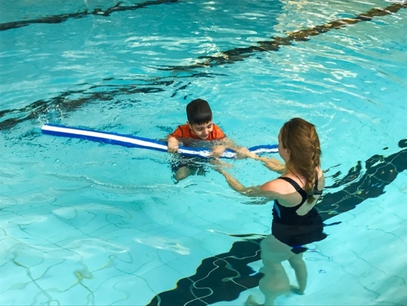
- Here are a few thoughts on how to adapt community activities that other parents have used in the past:
- Get other participants involved in guiding your child and describing what to do.
- A volunteer (e.g., an older child belonging to the club) can buddy up with your child during lessons and/or outings and special activities.
- Dance, skating and other similar instructors may opt to wear brightly coloured gloves and/or items like skate wraps so they stand out.
- During swimming lessons for children with low vision, use a large object in a contrasting colour to mark the end of a lane. Children who are blind will need a “tapper,” i.e., a guide with a long pole to indicate when to turn around. This technique requires a certain level of maturity and a lot of practice. It is generally reserved for school-aged children.
Watch video #9 - 4 to 5 years

Conclusion
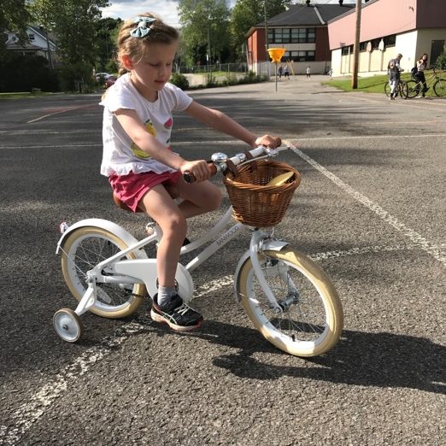
We hope these tips have been, and will continue to be, helpful to you and your child along your journey. Let us conclude by reiterating that you know your child better than anyone else. You are the person who can best identify and interpret their needs. But never hesitate to reach out and ask for help. The list of resources in this guide is a great place to start.
Sometimes, it can be a challenge to motivate your child to overcome their fears and hesitations and push themselves forward. But keep nudging them, gently but firmly, and turn it into a game whenever you can.
By giving your child a good start now, you will be building up their skill sets and giving them the gift of self-confidence. You will be letting them experience their first victories and putting them on the path to an active lifestyle. As a parent, you are their first teacher, their first guide, their first cheerleader, especially during these first five years of life. Remember: there are three things your child needs to acquire fundamental movement skills:
- The right tools and implements
- Room to move and an environment conducive to physical activity
- The support of the people around them.
Be their inspiration by setting an example and remaining active yourself. There’s no need to be an elite athlete: just get out and get moving as much as possible.
One last and very important point: don’t overlook your own needs as a parent. We encourage you to reach out to the AQPEHV and other organizations for guidance and parent support groups. Having someone to listen, understand and share ideas with can make all the difference!

Some Helpful Resources

- Association québécoise des parents d’enfants handicapés visuels.
- Régie de l’assurance maladie du Québec: Accredited facilities specializing in the rehabilitation of persons with a visual impairment.
- Resources For Parents With Visually Impaired Children: https://www.visionofchildren.org/voc-blog/2018/5/11/resources-for-parents-with-visually-impaired-children.
- Bouger avec cœur été comme hiver: Layout 1 (stationfamilles.org); Comité Santé et Bien-être Ahuntsic, in partnership with Québec en forme. (In French).
- Jouer aux exercices, Kino-Québec: www.kino-quebec.qc.ca. (in French).
- Video with Ingrid Roques, kinesiologist, produced by Caméra Cristalline. Techniques for promoting mobility in babies up to 18 months (in French).
- Table sur le mode de vie physiquement actif: Documents on motor development, active play, free play and outdoor play. Link #1 (in French). Link #2.
- Canadian Society for Exercise Physiology: 24-Hour Movement Guidelines, updated in 2020: 24-Hour Movement Guidelines – Canadian 24-Hour Movement Guidelines (csepguidelines.ca).
- AQPEHV: Mille et une réponses – La petite enfance, updated 2021. (In French).
- The Best in Daily Life: Resources for families with children aged 0–2 years that are born preterm or with other health issues.
- VIEWS ON, Views for the Visually Impaired: ViewsOn.
- CNIB Foundation - Info and Resources: Sight Loss Info | CNIB.
- Blind Beginning - ORGANIZATIONS SUPPORTING BC CHILDREN & YOUTH : Organizations Supporting BC Children & Youth – Blind Beginnings.
- APSEA (Atlantic Provinces Special Education Authority) - Families and Students: Families & Students | APSEA.

Acknowledgements

Thank you to all the parents of children with a visual impairment who shared their experiences with us: Hind Armaze, Nadia Bélanger, Mélissa Bérard, Sophie Bouchard, Isabelle D’Avignon, Caroline Grover, Roxanne Lafrance, Sabrina Leclerc, Isabelle Lessard, Catherine Paillé, Nathalie Rhéaume, Joanie Rondeau.
Thank you to Maude Demers-Bonin, an occupational therapist with Institut Nazareth et Louis Braille, for reviewing this document and for help in finding participants and photographs. Thank you to Institut Nazareth et Louis Braille for letting Maude invest time in this project.
Thank you to the visual impairment program of the Institut de réadaptation en déficience physique de Québec for their help in finding participants and photographs.
Thank you to the Association québécoise des parents d’enfants handicapés visuels for their help in finding photographs and participants for our videos.
Thank you to Michael Lonergan and the British Columbia Blind Sports and Recreation Association for sharing their work with us.
Thank you to Martine D’Amour for her copyediting services.
Thank you to EVOQ communications and Shonda Secord for the English translation.

References

Scientific papers and literature reviews
Camaret Ninu, É. (2016). Place et rôle de la vision dans le développement sensorimoteur de l’enfant Contraste(43), 39–65.
Columna, L. Haibach, P. Lieberman, L. Fernández-Vivó, M. Cordero-Morales, I. (2016). Motor Development and Physical Activities for Families of Children with Visual Impairments and Blindness. Journal or Blindness Innovation and Research, Vol. 6, No. 1. Retrieved at: Motor Development and Physical Activities for Families of Children with Visual Impairments and Blindness (nfb.org)
Dwyer, A. (2017). Factors That Increase Physical Activity in Youth Who Are Visually Impiared. The College at Brockport: State University of New York. Kinesiology, sport studies, and physical education synthesis projects. Retrieved at: Factors That Increase Physical Activity in Youth Who Are Visually Impiared (brockport.edu)
Furtado, O. L., Allums-Featherston, K., Lieberman, L. J., & Gutierrez, G. L. (2015). Physical activity interventions for children and youth with visual impairments. Adapted Physical Activity Quarterly, 32(2), 1156–1176. doi:10.1123/apaq.2014-0164
Goyette, M. (2016). Intervenir auprès des parents: effets sur la pratique d’activités physiques et les habiletés motrices d’enfants âgés de 3 à 5 ans. Mémoire présenté à la faculté d’éducation physique et sportive, Université de Sherbrooke. Retrieved at: Activité physique et développement des habiletés motrices des enfants de 3 à 5 ans (usherbrooke.ca).
Jalbert, Y. Champagne P.O. et al. (2005). Le développement de la conscience de l’écrit chez l’enfant aveugle âgé de 0 à 5 ans: Recension des écrits. Institut Nazareth et Louis Braille. Retrieved at: Le développement de la conscience de l’écrit chez l’enfant aveugle âgé de 0 à 5 ans (inlb.qc.ca).
Norris, M. L., Toole, K. M., & Columna, L. (2018). Educating parents in aquatics activities for children with visual impairmentsw. British Journal of Visual Impairment, 36(3), 262–273. doi:10.1177/0264619618784631
Sadowska, D., Stemplewski, R., & Szeklicki, R. (2017). Postural Control in Young People with Visual Impairments and Various Risks of Falls. Journal of Visual Impairment & Blindness, 111(3), 261-270. doi:10.1177/0145482X1711100306
Scally, J. B., & Lord, R. (2019). Developing physical activity interventions for children with a visual impairment: Lessons from the First Steps initiative. British Journal of Visual Impairment, 37(2), 108–123. doi:10.1177/0264619618823822
Tranchon C. (2008). REGARD PSYCHOMOTEUR SUR LA DEFICIENCE VISUELLE AU COURS DE LA VIE :: Approches psychomotrices et sensorielles des déficiences visuelles précoces et tardives. Mémoire présenté à l’Institut Supérieur de Rééducation Psychomotrice. Retrieved from: helpinternet.free.fr/Memoire/.
Scientific abstracts and literature reviews
De Schipper, T. Lieberman, L.J. Moody, B. (2017). Kids like me, we go lightly on the head: Experiences of children with a visual impairment on the physical self-concept. British Journal of Visual Impairment, Vol. 35. Issue 1. Retrieved from: “Kids like me, we go lightly on the head”: Experiences of children with a visual impairment on the physical self-concept - Tessa de Schipper, Lauren J Lieberman, Brigitte Moody, 2017 (sagepub.com)
Fotiadou, E. Christodoulou, P. Soulis, S.G. Tsimaras, V.K. Mousouli, M. (2014). Motor Development and Self-Esteem of Children and Adolescents with Visual Impairment. Journal of Education Practice, Vol. 5, No. 37. Retrieved at: Motor Development and Self-Esteem of Children and Adolescents with Visual Impairment | Fotiadou | Journal of Education and Practice (iiste.org)
Haibach, P.S. Wagner, M.O. Lieberman, L.J. (2014). Determinants of gross motor skill performance in children with visual impairments. Research in Developmental Disabilities, Vol. 35, Issue 10 (2577–2584). Retrieved at: Determinants of gross motor skill performance in children with visual impairments - ScienceDirect
Williams, G. Aggio, D. Stubbs, B. Pardhan, S. Gardner, B. Smith, L. (2018). Physical activity levels in children with sensory problems: Cross-sectional analyses from the Millennium Cohort Study. Disability and Health Journal. Vol. 11, Issue 1 (58–61). Retrieved at: Physical activity levels in children with sensory problems: Cross-sectional analyses from the Millennium Cohort Study - ScienceDirect
Web pages
Baillargeon, M. (1986). Les déficiences visuelles: effets sur le développement. Retrieved at: Les déficiences visuelles: Les effets sur le développement - AQPEHV
Cossin, M. (2019). L’équilibre, c’est renversant. Retrieved at: L’équilibre, c’est renversant | Agence Science-Presse
Ferland, F. (2014) – Éditions du CHU Ste-Justine: Le développement de l’enfant au quotidien de 0 à 6 ans. Retrieved at:https://www.editions-chu-sainte-justine.org/media/livre/document/253_Tableau_syntheIse_Dev_06ans.pdf
Formation Attention! Enfants en mouvement! Retrieved at: AEM_CahierParticipant_P43-58.indd (gpslaval.com).
French, K. (2020). Camp Spark: Using Sports and Physical Activity as a Catalyst for Independence. Visual Impairment and Deafblind Education Quarterly: Volume 65, Issue 1., 31–39. Retrieved at: VIDBEQ_65_1_Winter_2020.pdf (higherlogicdownload.s3.amazonaws.com)
Kino-Québec. (2008) Fiches d’information scientifique No 00189. Retrieved at: Le développement des habiletés motrices s’accompagne d’une amélioration des résultats scolaires de l’enfant (kino-quebec.qc.ca).
Kino-Québec, (2005). Fiche d’information scientifique No 00015. Retrieved at: Les facteurs associés à l’activité physique chez les enfants d’âge préscolaire (kino-quebec.qc.ca).
Kino-Québec. (2008). Fiche d’information scientifique No 00034. Retrieved at: Relation entre les habiletés motrices et la condition physique des enfants (kino-quebec.qc.ca).
Kino-Québec (2003). Fiche d’information scientifique No 00040. Retrieved at: Influence parentale et niveau d’activité physique des enfants (kino-quebec.qc.ca).
Ouellet, M.C. (2018). Les habiletés motrices, un atout pour la vie. ViFa (Article no 494). Retrieved at: Les habiletés motrices, un atout pour la vie | Vifa Magazine
Table sur le mode de vie physiquement actif, Gouvernement du Québec, Ministère de l’éducation et de l’enseignement supérieur. (2016). Version française : À nous de jouer!: Le développement moteur de l’enfant, un pilier important du développement global. (Publication no 978-2-550-76240-9). Retrieved at: DevMoteurEnfant.indd (fichier-pdf.fr). English Version: It’s Playtime! The motor development or the child: A key pillar or the global development. (Publication no 978-2-550-76240-9).
Books and documents
AQPEHV. (2002, Greenfield Park, QC). Mille et une réponses: la petite enfance. AQPEHV.
Blaine, J. D.; Lonergan, M. J. (2010, Vancouver). Encouraging Physical Activity For Preschoolers with Visual Impairment: A Resource for Parents. BC Blind Sport and Recreation Association. Bartoszewski, Dorothy. and DVD.
Ferrell, K. A. (2011, New York, NY). Reach out and teach: helping your child who is visually impaired learn and grow. AFB Press.
Inserm (dir.). (Expertise collective). (2002). Déficits visuels: Dépistage et prise en charge chez le jeune enfant. Rapport. Extrait: Chapitre 2: Développement de la personne déficiente visuelle (p.25–43). Paris: Les éditions Inserm. Retrieved from: www.ipubli.inserm.fr/bitstream/handle/10608/163/?sequence=7
Nielsen, L. (2010, Talant). Apprentissages précoces pas à pas, chez les enfants déficients visuels avec ou sans troubles associés. Les doigts qui rêvent.
Raynor, Sherry, Drouillard, Richard and Huard, Jean. (1980, Longueuil, QC). Et que ça bouge!: un guide destiné aux parents d’enfants handicapés visuels. Institut Nazareth et Louis Braille.
Simmons, S. S. and O’Mara Maida, S. (1992, Los Angeles Calif). Reaching, crawling, walking ... let’s get moving: orientation and mobility for preschool children. Blind Children’s Center.

Association sportive des aveugles du Québec
Quebec Blind Sport Association
4545 Pierre-de Coubertin Avenue
Montreal, Quebec H1V 0B2
514-252-3178
sportsaveugles.qc.ca
infoasaq@sportsaveugles.qc.ca
Follow us on Facebook!

Copyright ASAQ © 2022.All rights reserved.
This work may not be used or reproduced in any form, in whole or in part,
without the permission of the author.

