PRESS RELEASE
For immediate release

A TOURNAMENT PLAYED IN THE MOST COMPLETE SILENCE:
The 19th edition of the Montreal Open Goalball Tournament

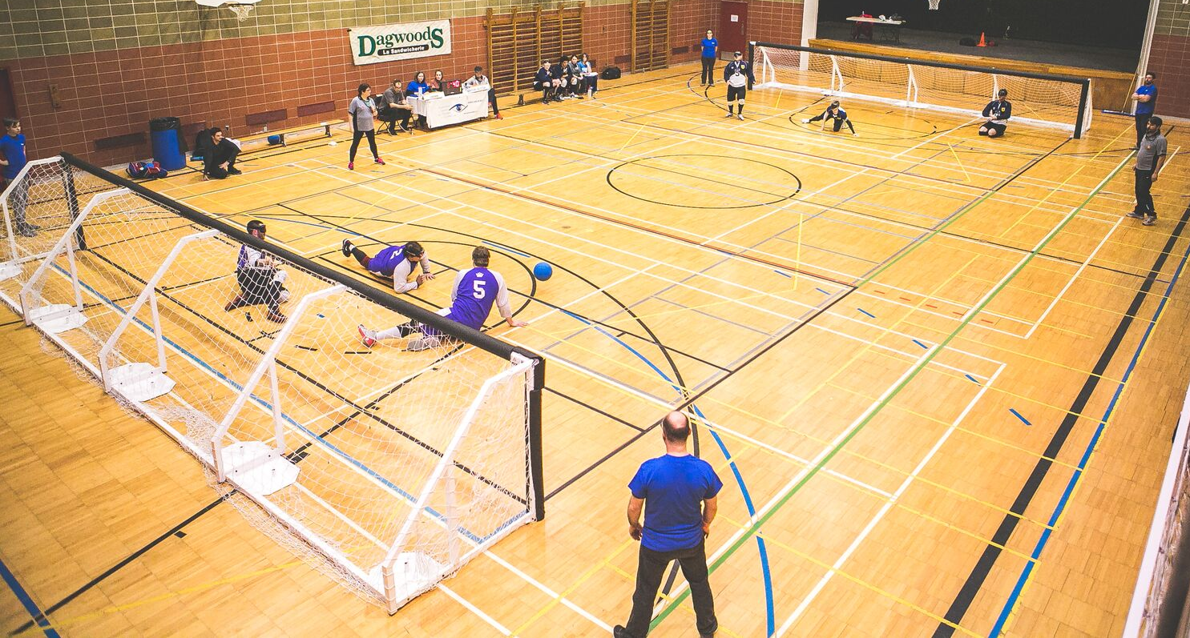

Montreal, January 22nd, 2019 – The Quebec Blind Sports Association (Association sportive des aveugles du Québec or ASAQ)’s team, led by Nathalie Chartrand, executive director and Paralympic medalist in goalball, is fine-tuning the details of the annual Montreal Open Goalball Tournament (MOGT). For its nineteenth consecutive year, the event will be held from Friday, January 25 to Sunday, January 27,, 2019 at the Gadbois Recreational Complex located at 5485, Chemin de la Côte-Saint-Paul in Montreal.

During this 19th edition, thirteen Canadian and American teams, including nine masculine and four feminine ones, will compete to win the title of best team of the year. Pools A and B will be composed of the men's teams from British Columbia, Alberta, Ontario (All Blacks), Nova Scotia, California (Crown), New Jersey (Titans), Delaware (Goon Squad), Washington DC (DC Eagles) and Quebec. Pool C will be composed of the women's teams from Alberta, Ontario (All Blacks), British Columbia and Nova Scotia.

Our Quebec team will be composed of the athletes Bruno Haché from Dorval, Simon Tremblay from Val-Belair and Rakibul Karim from Montreal. They will be accompanied by their coach Nathalie Séguin and the assistant coach Viviane Marcotte-L'Heureux.

The presentation of the 2019 edition of the MOGT is made possible thanks to the participation of about fifty volunteers and the financial support of our generous funders and sponsors: ministère de l’Éducation et de l’Enseignement supérieur, City of Montreal, Pepsi Canada, Physiothérapie Claude-Robillard, Protection Incendie Idéal Inc. (Laval and Quebec), Défi Sportif, Hôtel Espresso Montréal Centre-Ville/Downtown, Les Jardins Dauphinais and Location Légaré.

The ASAQ invites sports enthusiasts and the general public to go to the Gadbois Recreational complex this weekend to encourage athletes living with visual impairments. It will also be an opportunity to discover the goalball, this unique sport that is played in the most complete silence. The admission is free!

All the details of the tournament as well as the schedule of the 34 games are available on our website at the following link: Montreal Open Goalball Tournament (TOGM)

About goalball

Goalball was invented after the Second World War as a means of rehabilitation for people who became blind during the war. It entered the Paralympic Games in 1976 in Toronto, Canada.

Goalball is a team sport specifically designed for people with visual impairments. Played in a gymnasium, the goal of the game is to roll or bounce a ball that contains a bell, so that it penetrates the goal of the opposing team while opponents try to block the ball with their body. To equalize the odds between blind and visually impaired players, they must all wear a blindfold. The goalball court is bounded by a strip of tape under which a string in the center creates a tactile line. In this way players can orient themselves in the court.

It is a unique sport for the spectator given the absolute silence required to facilitate the concentration of athletes.

-30-
Information and interview requests:
Surainy Jimenez | Communications officer
Association sportive des aveugles du Québec
communications@sportsaveugles.qc.ca

