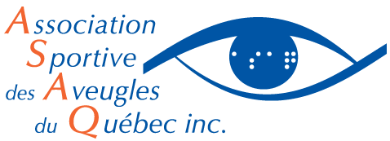

Calendar - Junior goalball at the MAB-Mackay (Montreal)
13 to 18 years old
Winter 2018

Date | Time
Tuesday, February 6th | 19h00 to 20h00
Tuesday, February 13th | 19h00 to 20h00
Tuesday, February 20th | 19h00 to 20h00
Tuesday, February 27th | 19h00 to 20h00
Tuesday, March 6th | 19h00 to 20h00
Tuesday, March 13th | 19h00 to 20h00
Tuesday, March 20th | 19h00 to 20h00
Tuesday, March 27th | 19h00 to 20h00
Tuesday, April 3rd | 19h00 to 20h00
Tuesday, April 11th | 19h00 to 20h00

Note: Date of tournament to be determined

Place and adress

- Layton Hall at MAB,
7010 Sherbrooke Street West, Montreal, QC H4B 1S5

Absences

Out of respect for our collaborators, kindly let us know in advance if your child will not attend by:
- On Tuesdays, Thursdays and Fridays: Calling 514-252-3178 ext. 3775 between 9h00 and 16h00
- The same day: Directly contacting the sports representative responsible for the activity

